**פרויקט סוף קורס** DevOps

**יותם גלעד-315819599** yotam.gilad@e.braude.ac.il

**תומר בן לולו-318318987 פלאפון-0546709087 מייל:**Tomer.Ben.Lolo@e.braude.ac.il

המשימה:

עליכם לפתור ולהגיש את המטלות הללו שמכסות את החומר שנלמד בהרצאות:

הרצאה 1. introduction – שקף 34

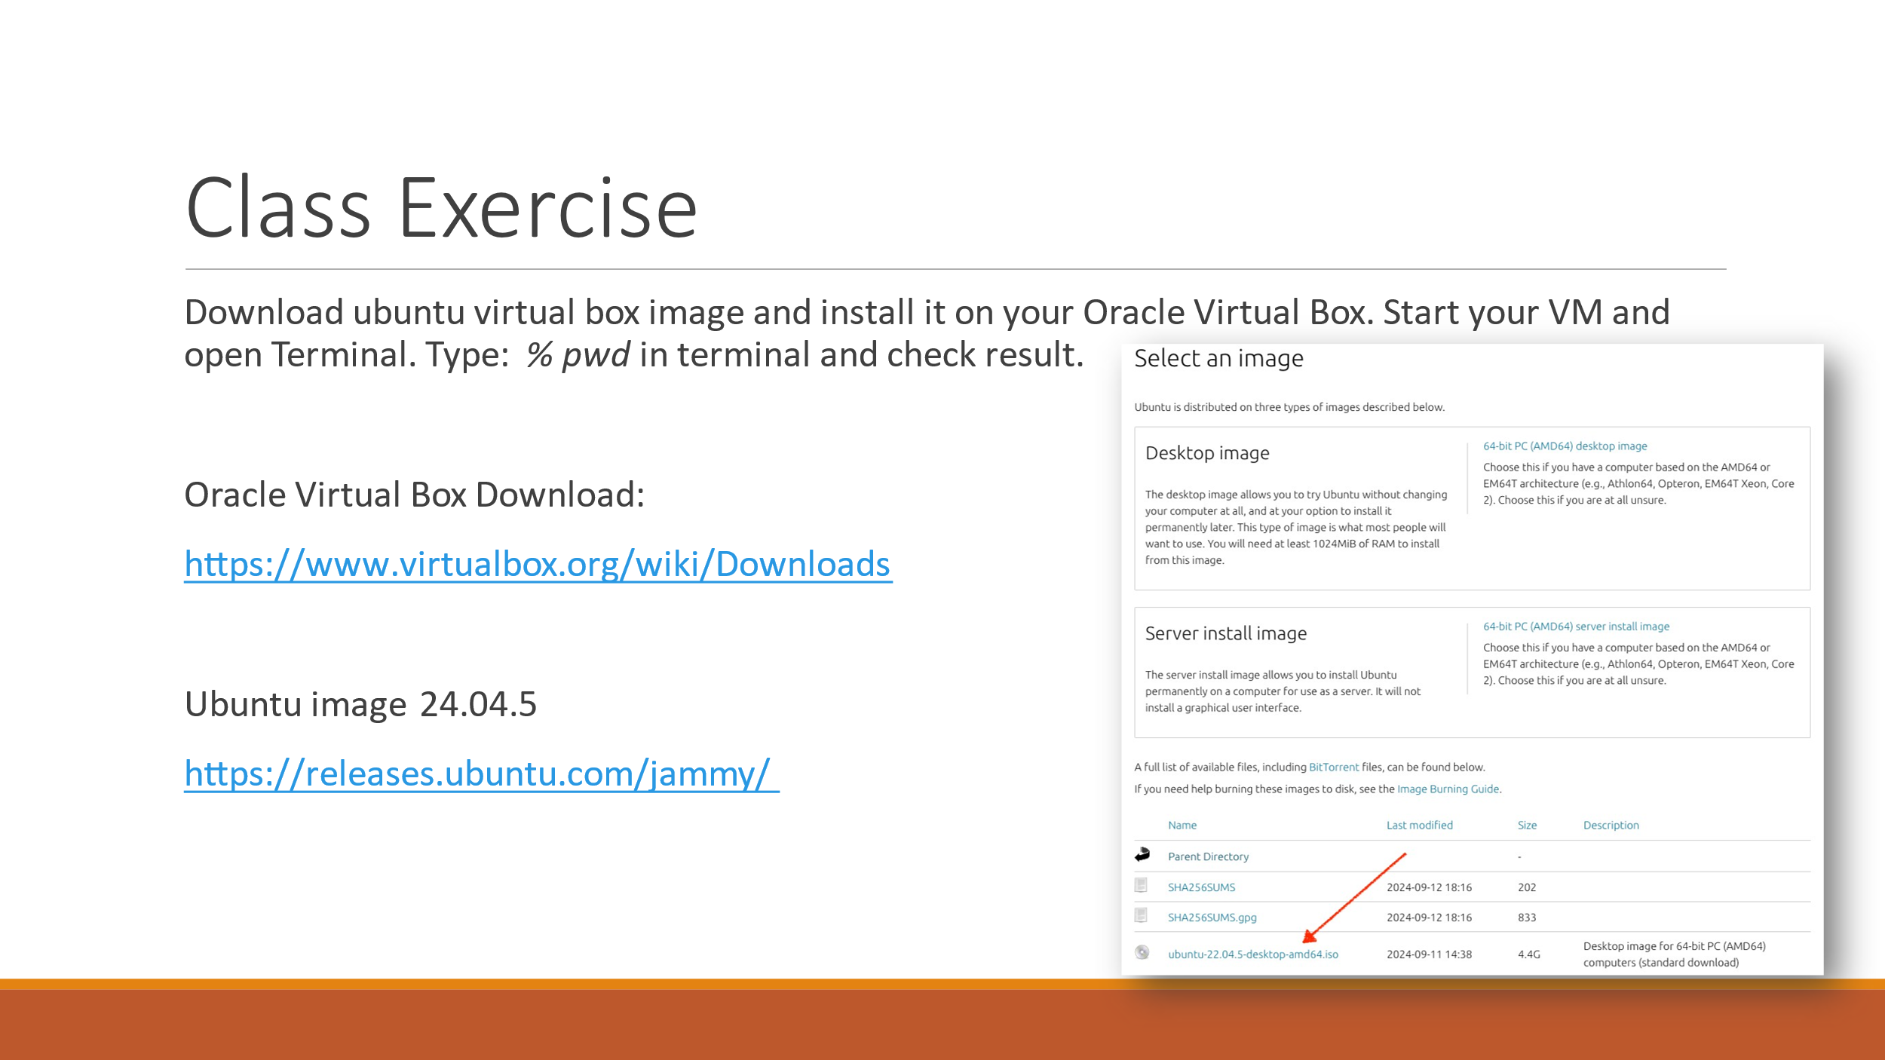Task:

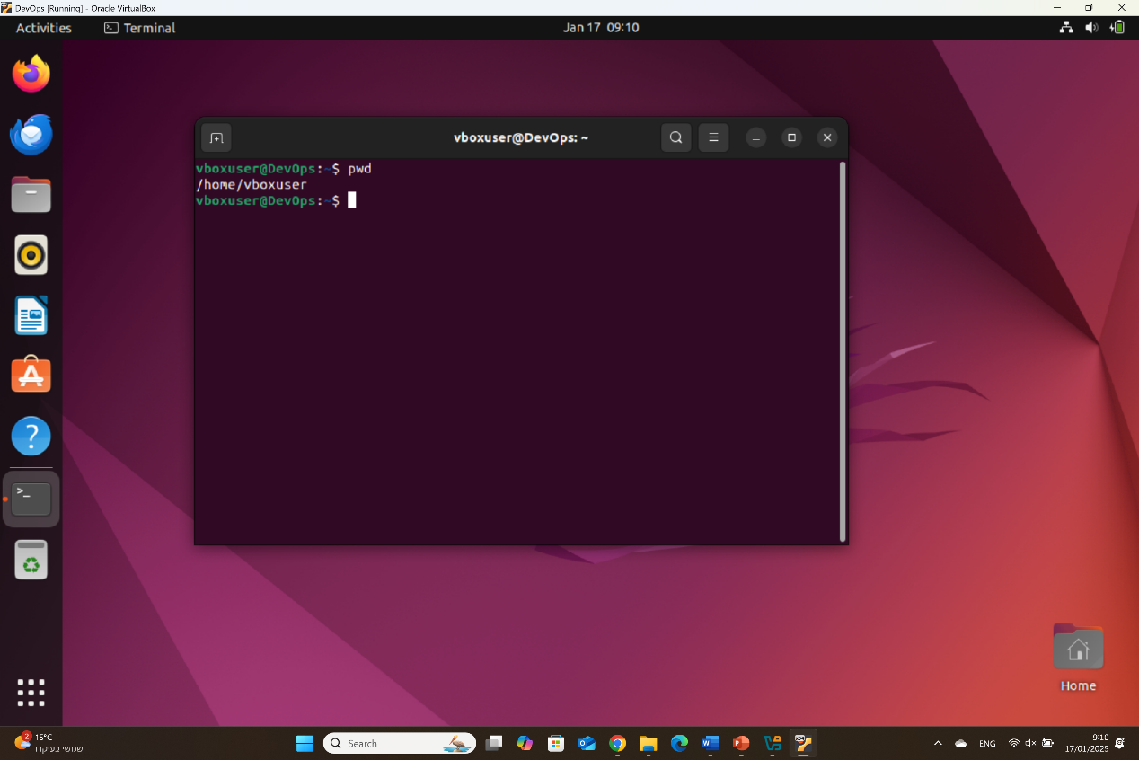

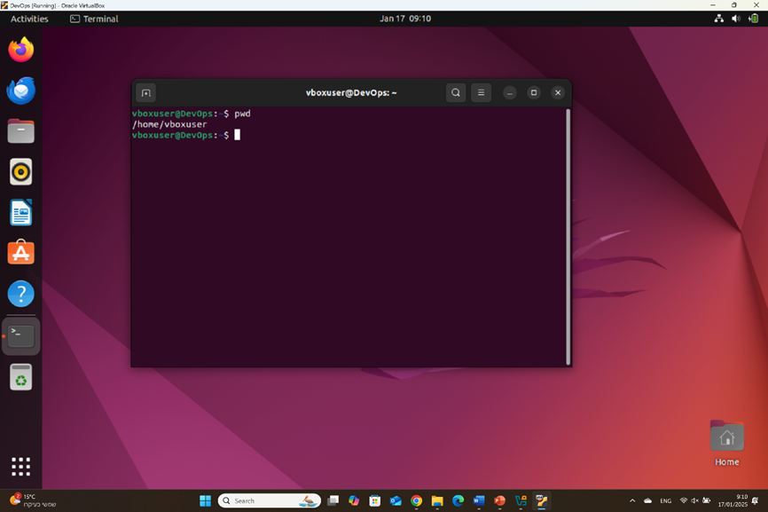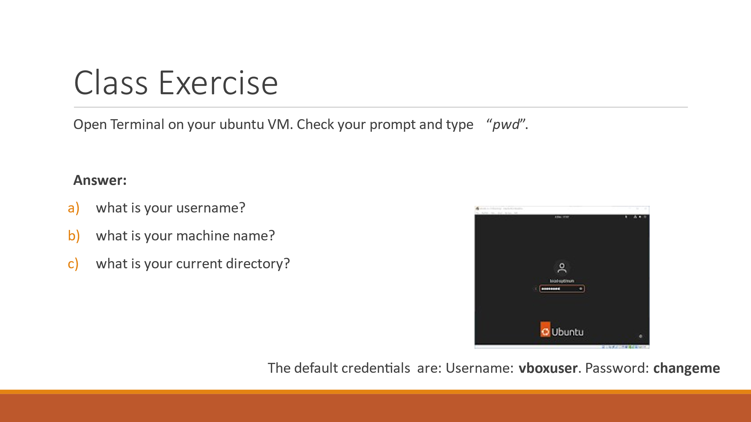הרצאה 2. linux – שקף 10,26,35

/home/vboxuser

DevOps

vboxuser

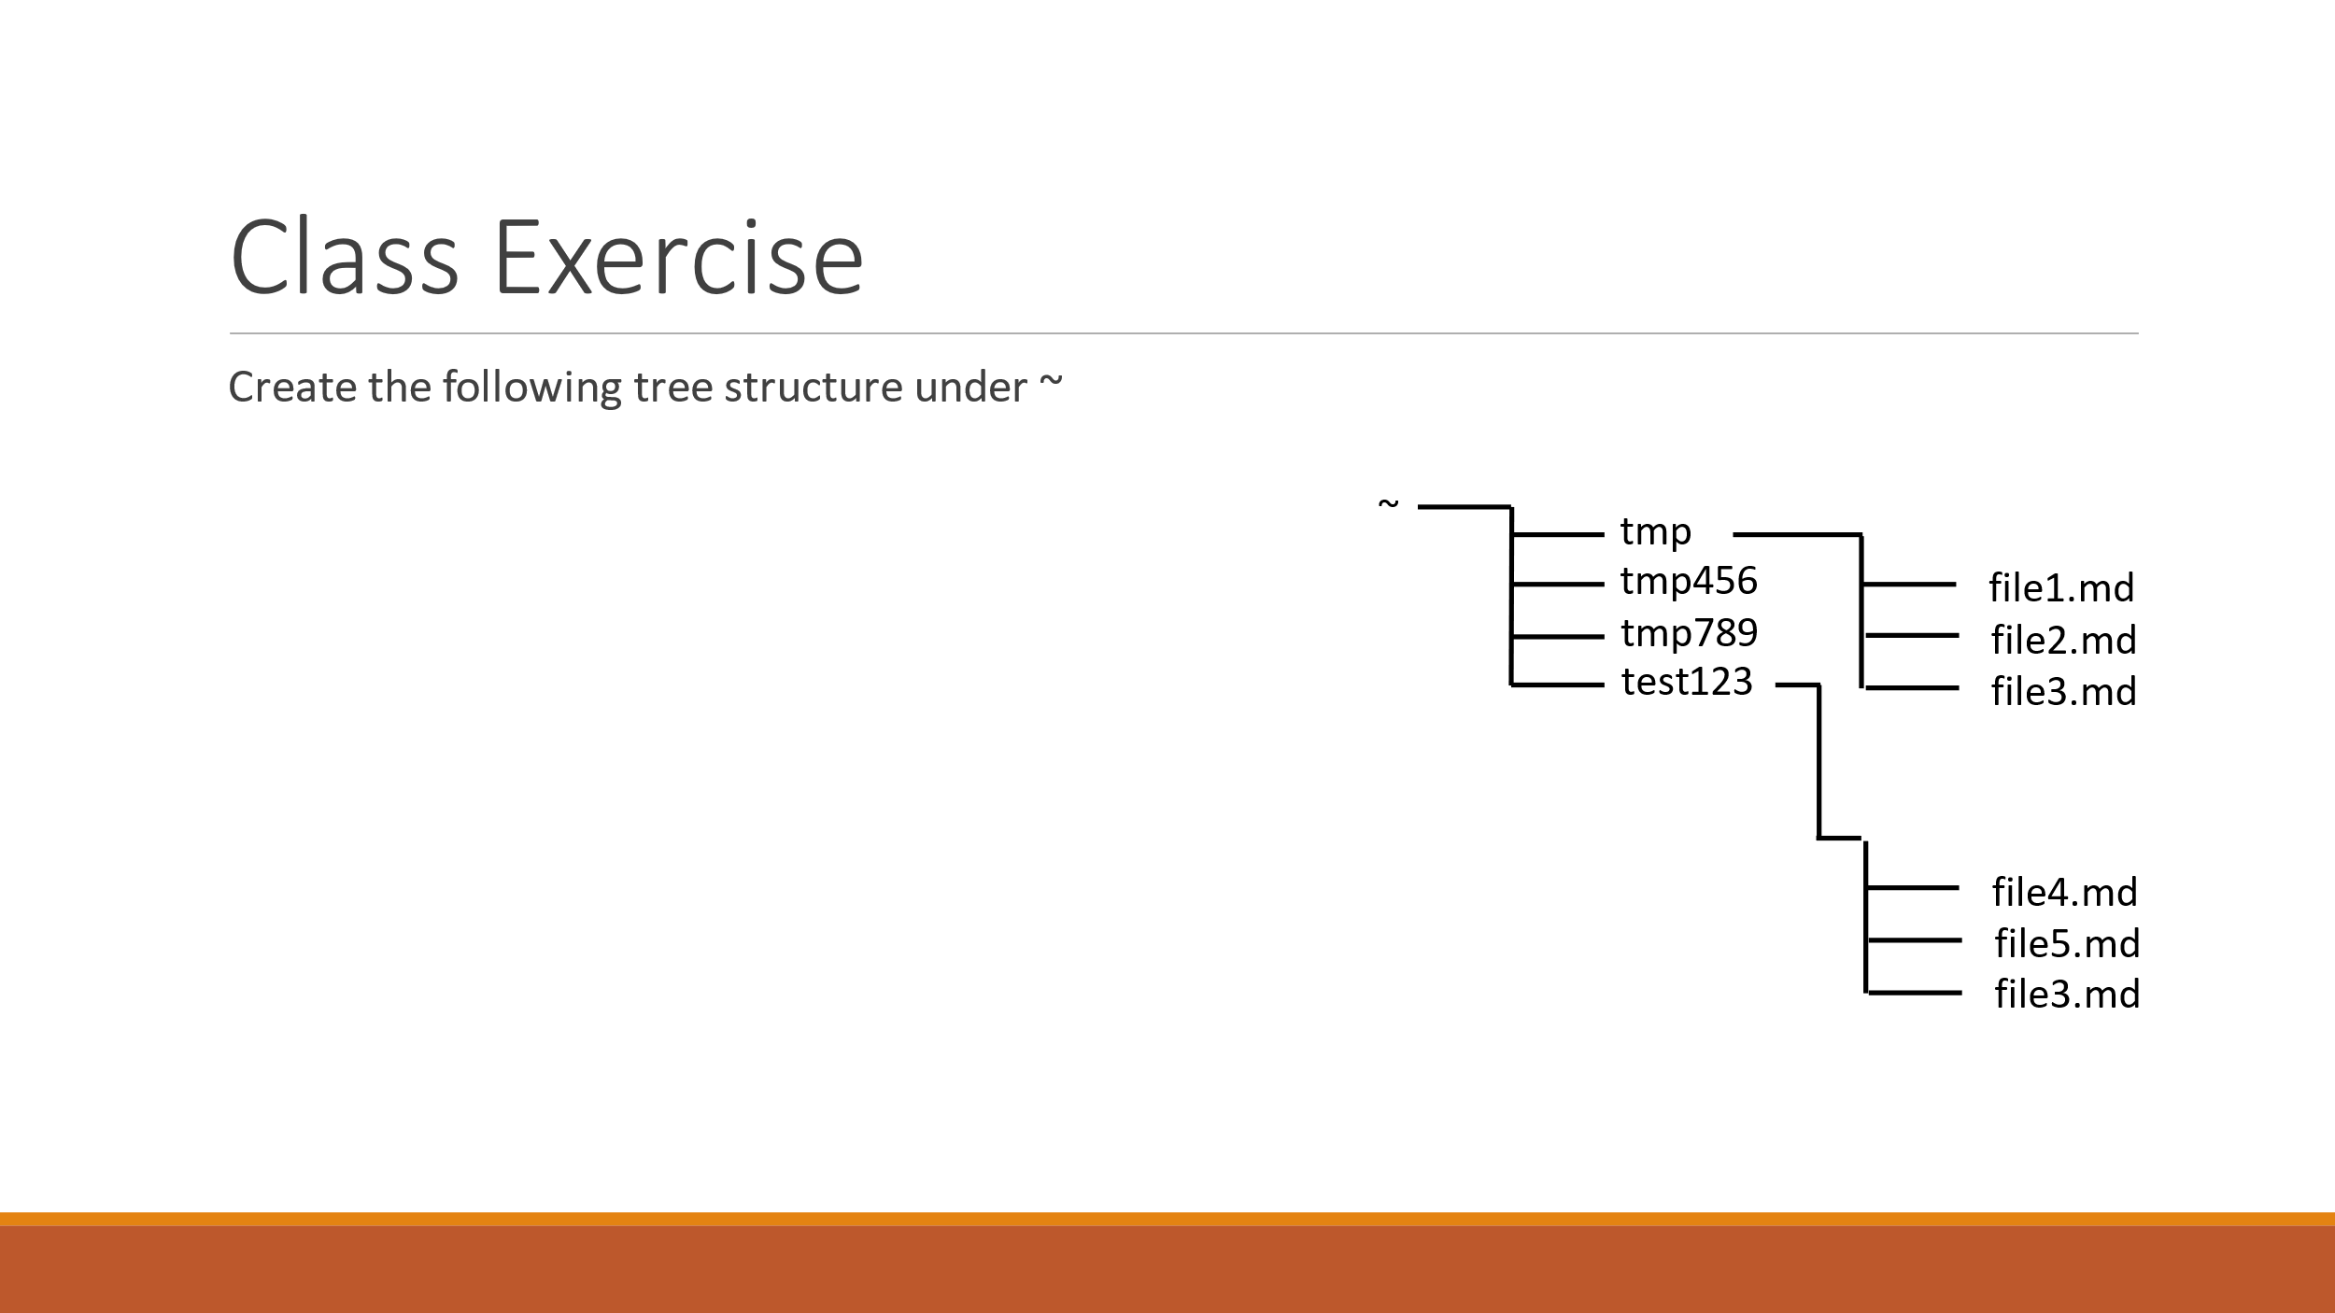Create directories and files according to the three presented in the following image:

Mkdir- create directory

Touch command to create file

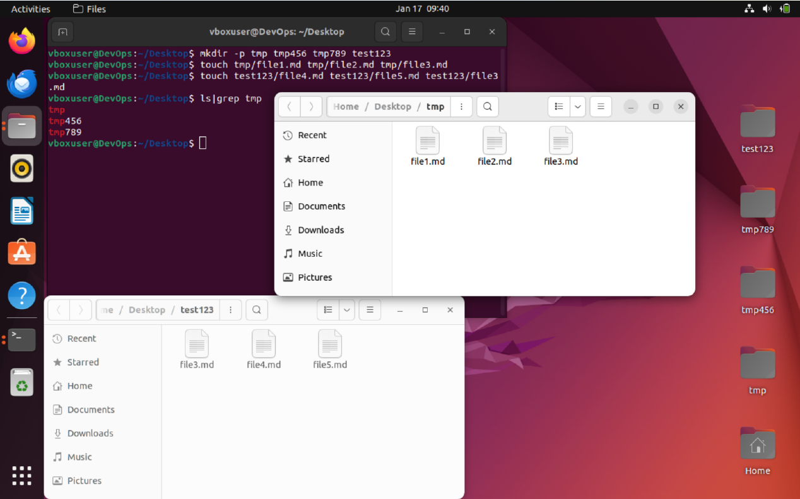

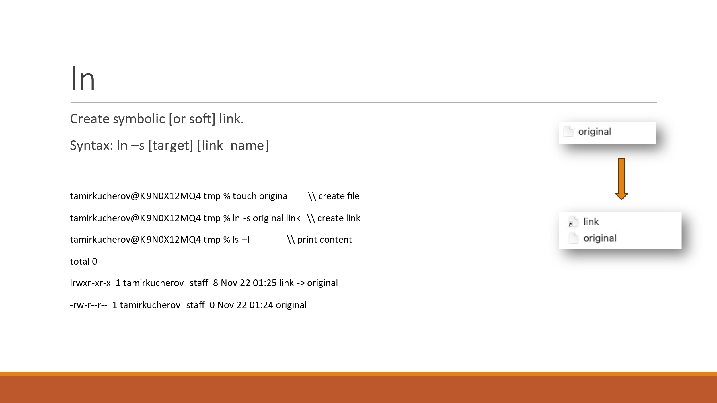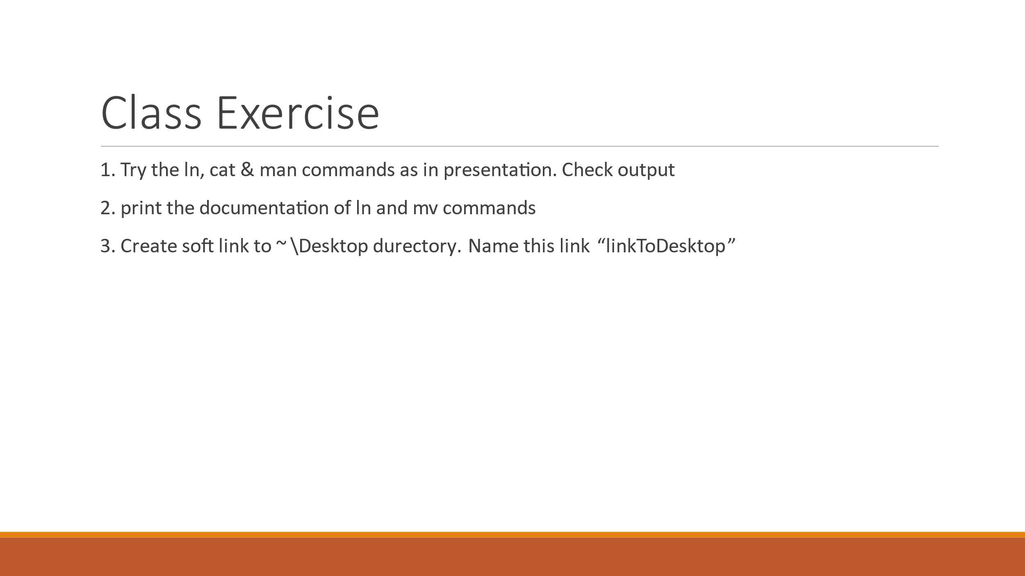

Create link to file

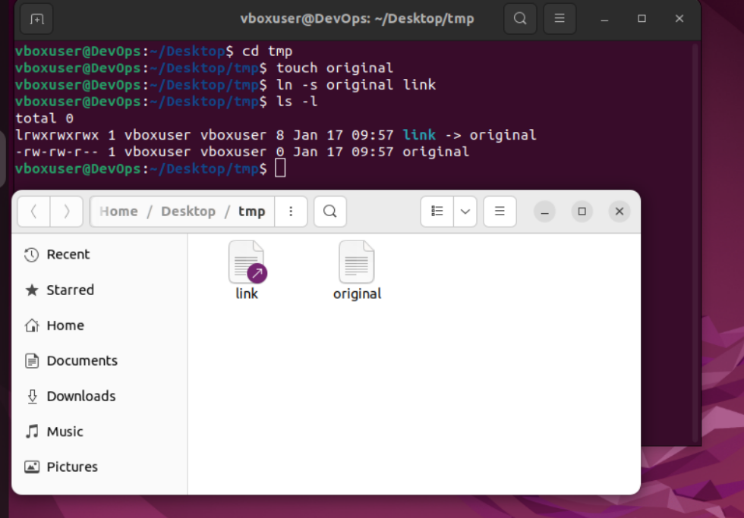

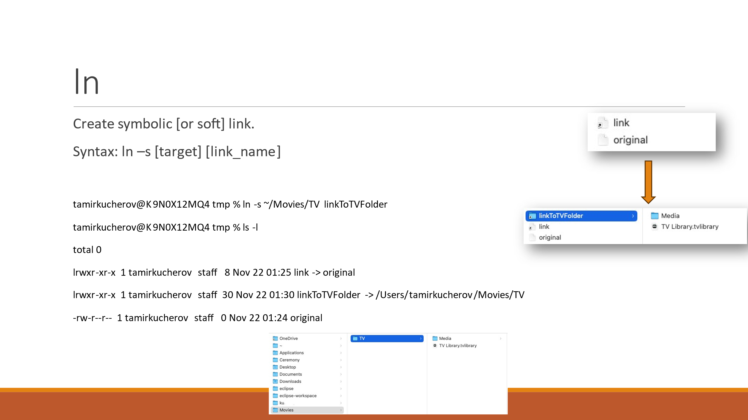create link to directory

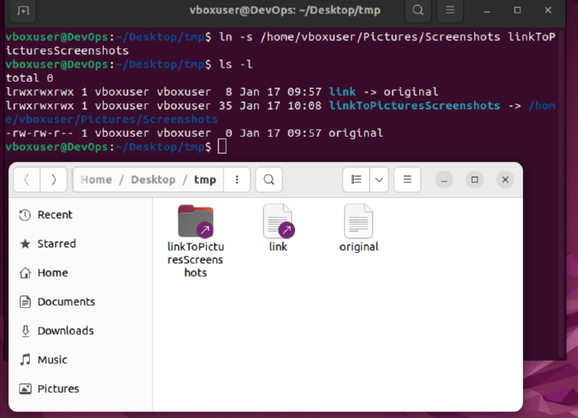

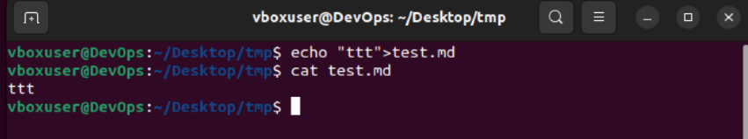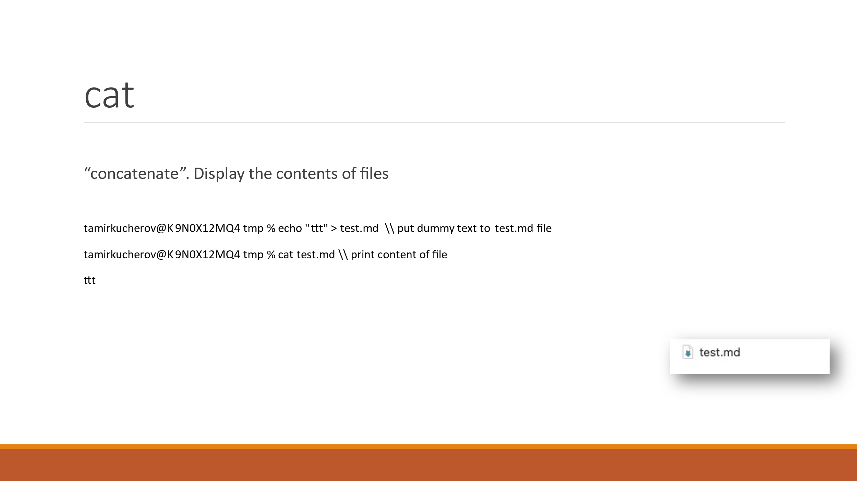Cat- display a content from file

Man command



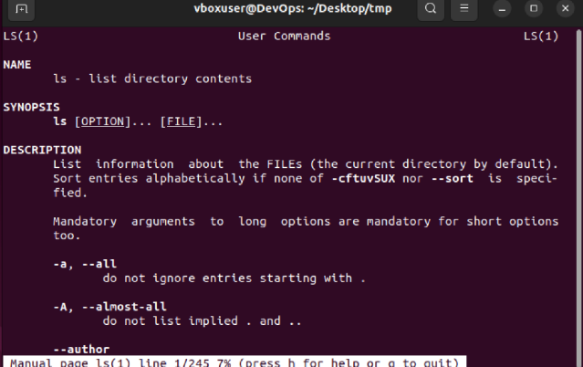

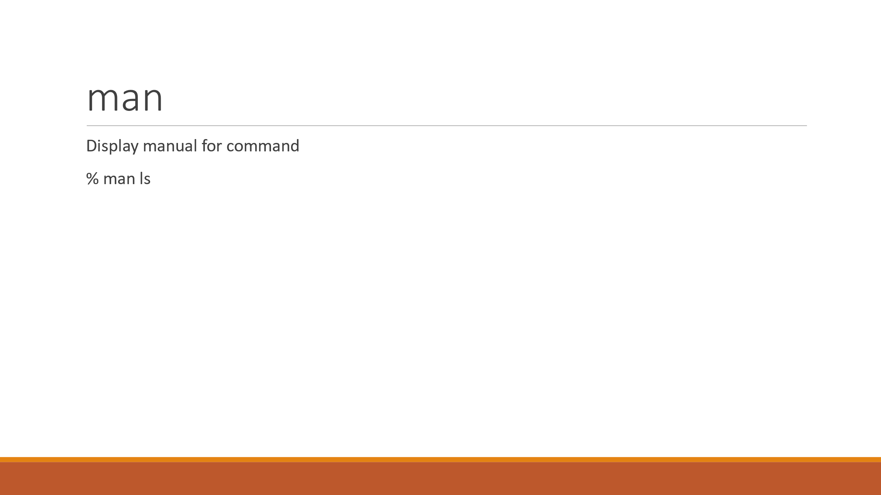

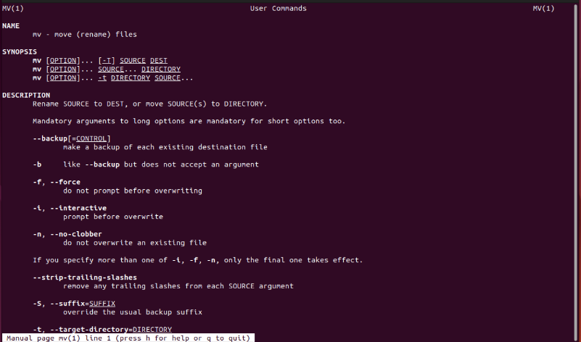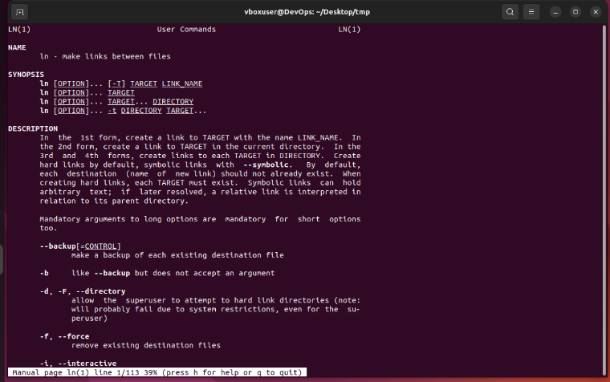

Create link to the desktop directory

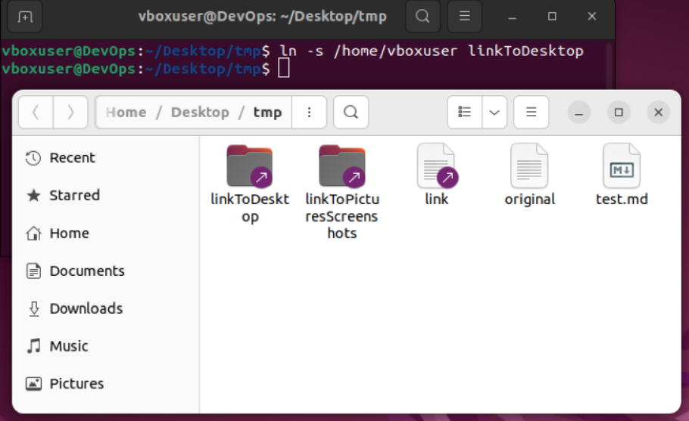

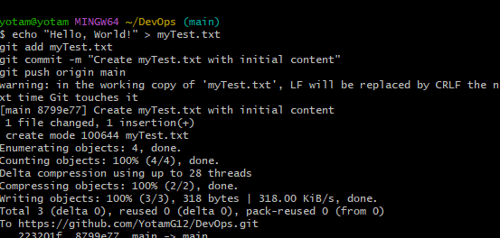הרצאה 3. git – שקף 46

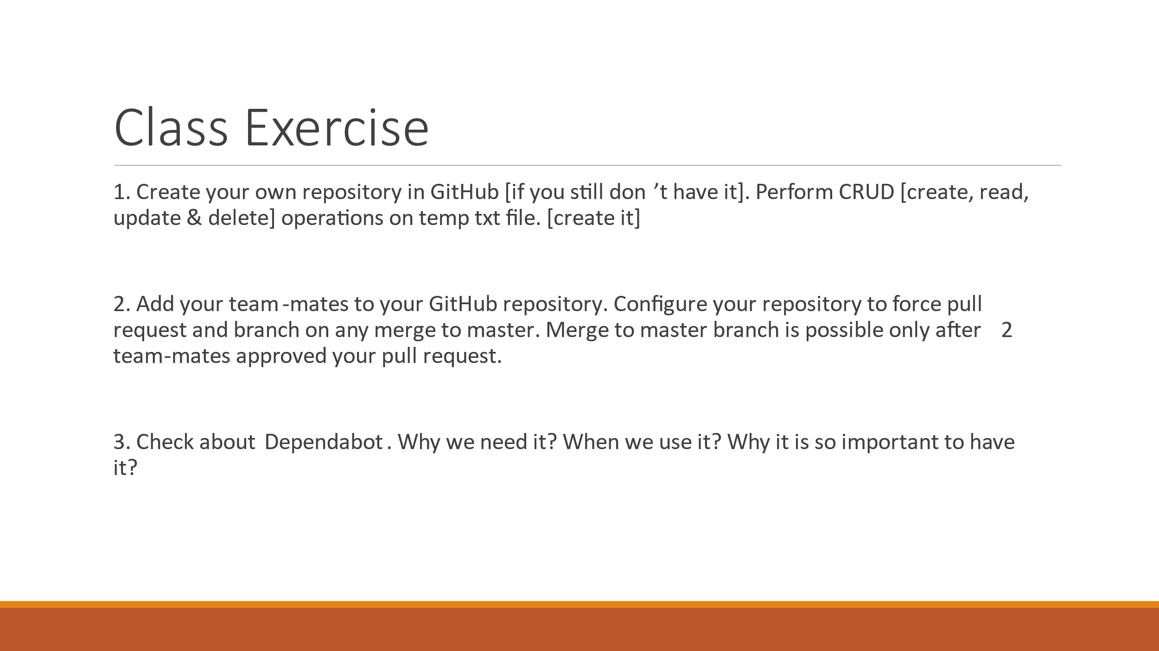

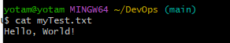 Create file and write inside a massege

Read from file:

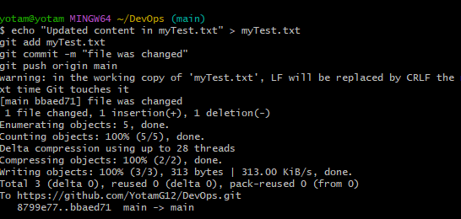

Update content in file.



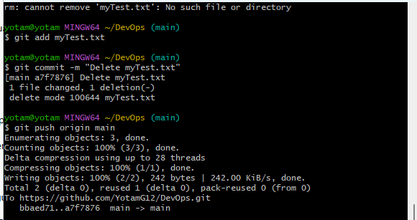delete the file from the repository

add team mate to edit in the repository

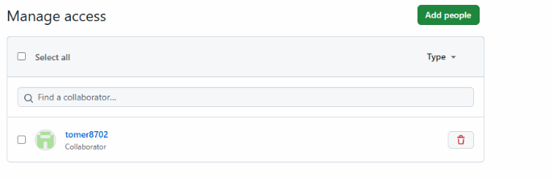

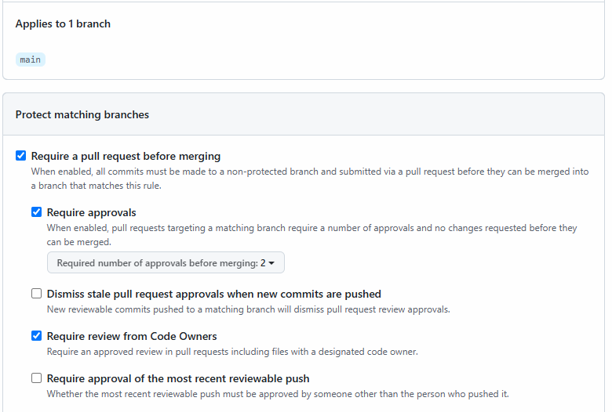manage to provide merge just if the two team mates approve the merging



**Why We Need Dependabot:**

1. **Security Patches:** Dependabot helps keep your dependencies up-to-date with the latest security fixes. This reduces the risk of vulnerabilities in your application.
2. **Avoiding Compatibility Issues:** It ensures that you are using compatible versions of libraries, preventing issues caused by outdated or incompatible dependencies.
3. **Automation:** It automates the process of keeping dependencies updated, saving time and effort, and reducing the possibility of human error.

**When Do You Use It?**

* **For Continuous Maintenance:** If your project depends on third-party libraries or packages, you should enable Dependabot to automatically handle dependency updates.
* **In Any Project With External Libraries:** If you're using npm, Python's pip, Ruby's Bundler, or any similar package managers, Dependabot can be configured to check and update dependencies for you.
* **For Security-Driven Projects:** If security is a priority, enabling Dependabot ensures you’re not exposed to known vulnerabilities in outdated dependencies.

**Why It's Important:**

1. **Security Compliance:** Many organizations require that dependencies be updated regularly to maintain security compliance.
2. **Easier Management:** Managing dependencies manually is error-prone and time-consuming. Dependabot automates the process, keeping your repository current and secure.
3. **Reduced Risk:** Outdated dependencies are often exploited by attackers. With Dependabot, you lower the chance of your project being compromised due to known vulnerabilities in libraries.

הרצאה 4. ansible – שקף 47

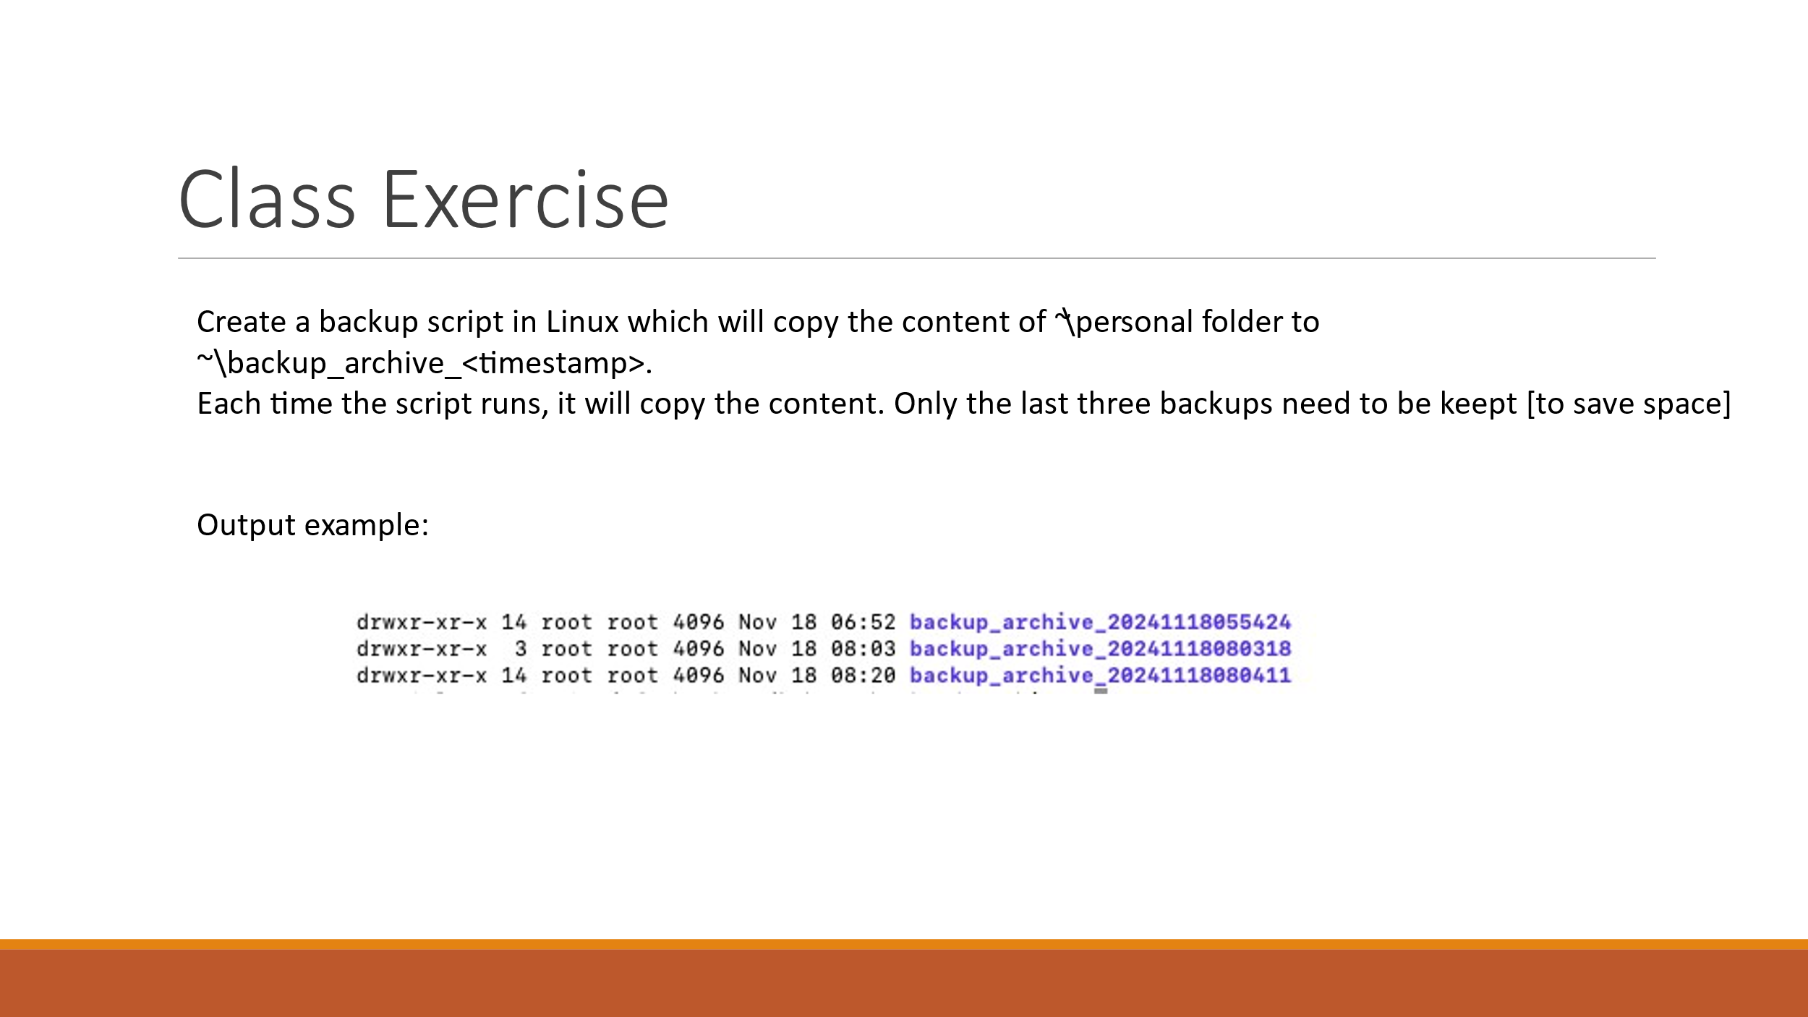

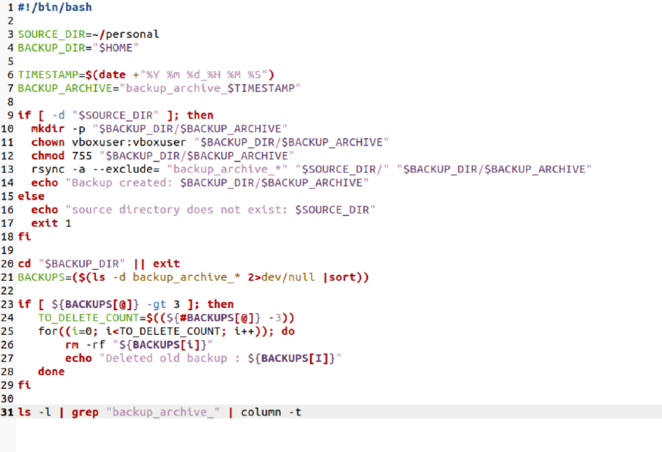



הרצאה 5. docker – שקף 29,33,45

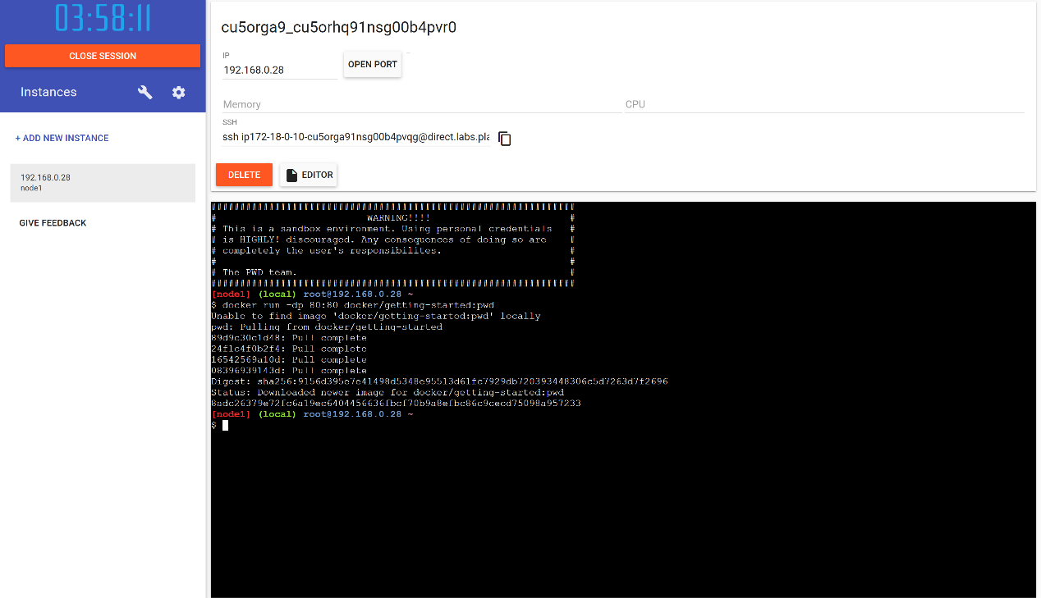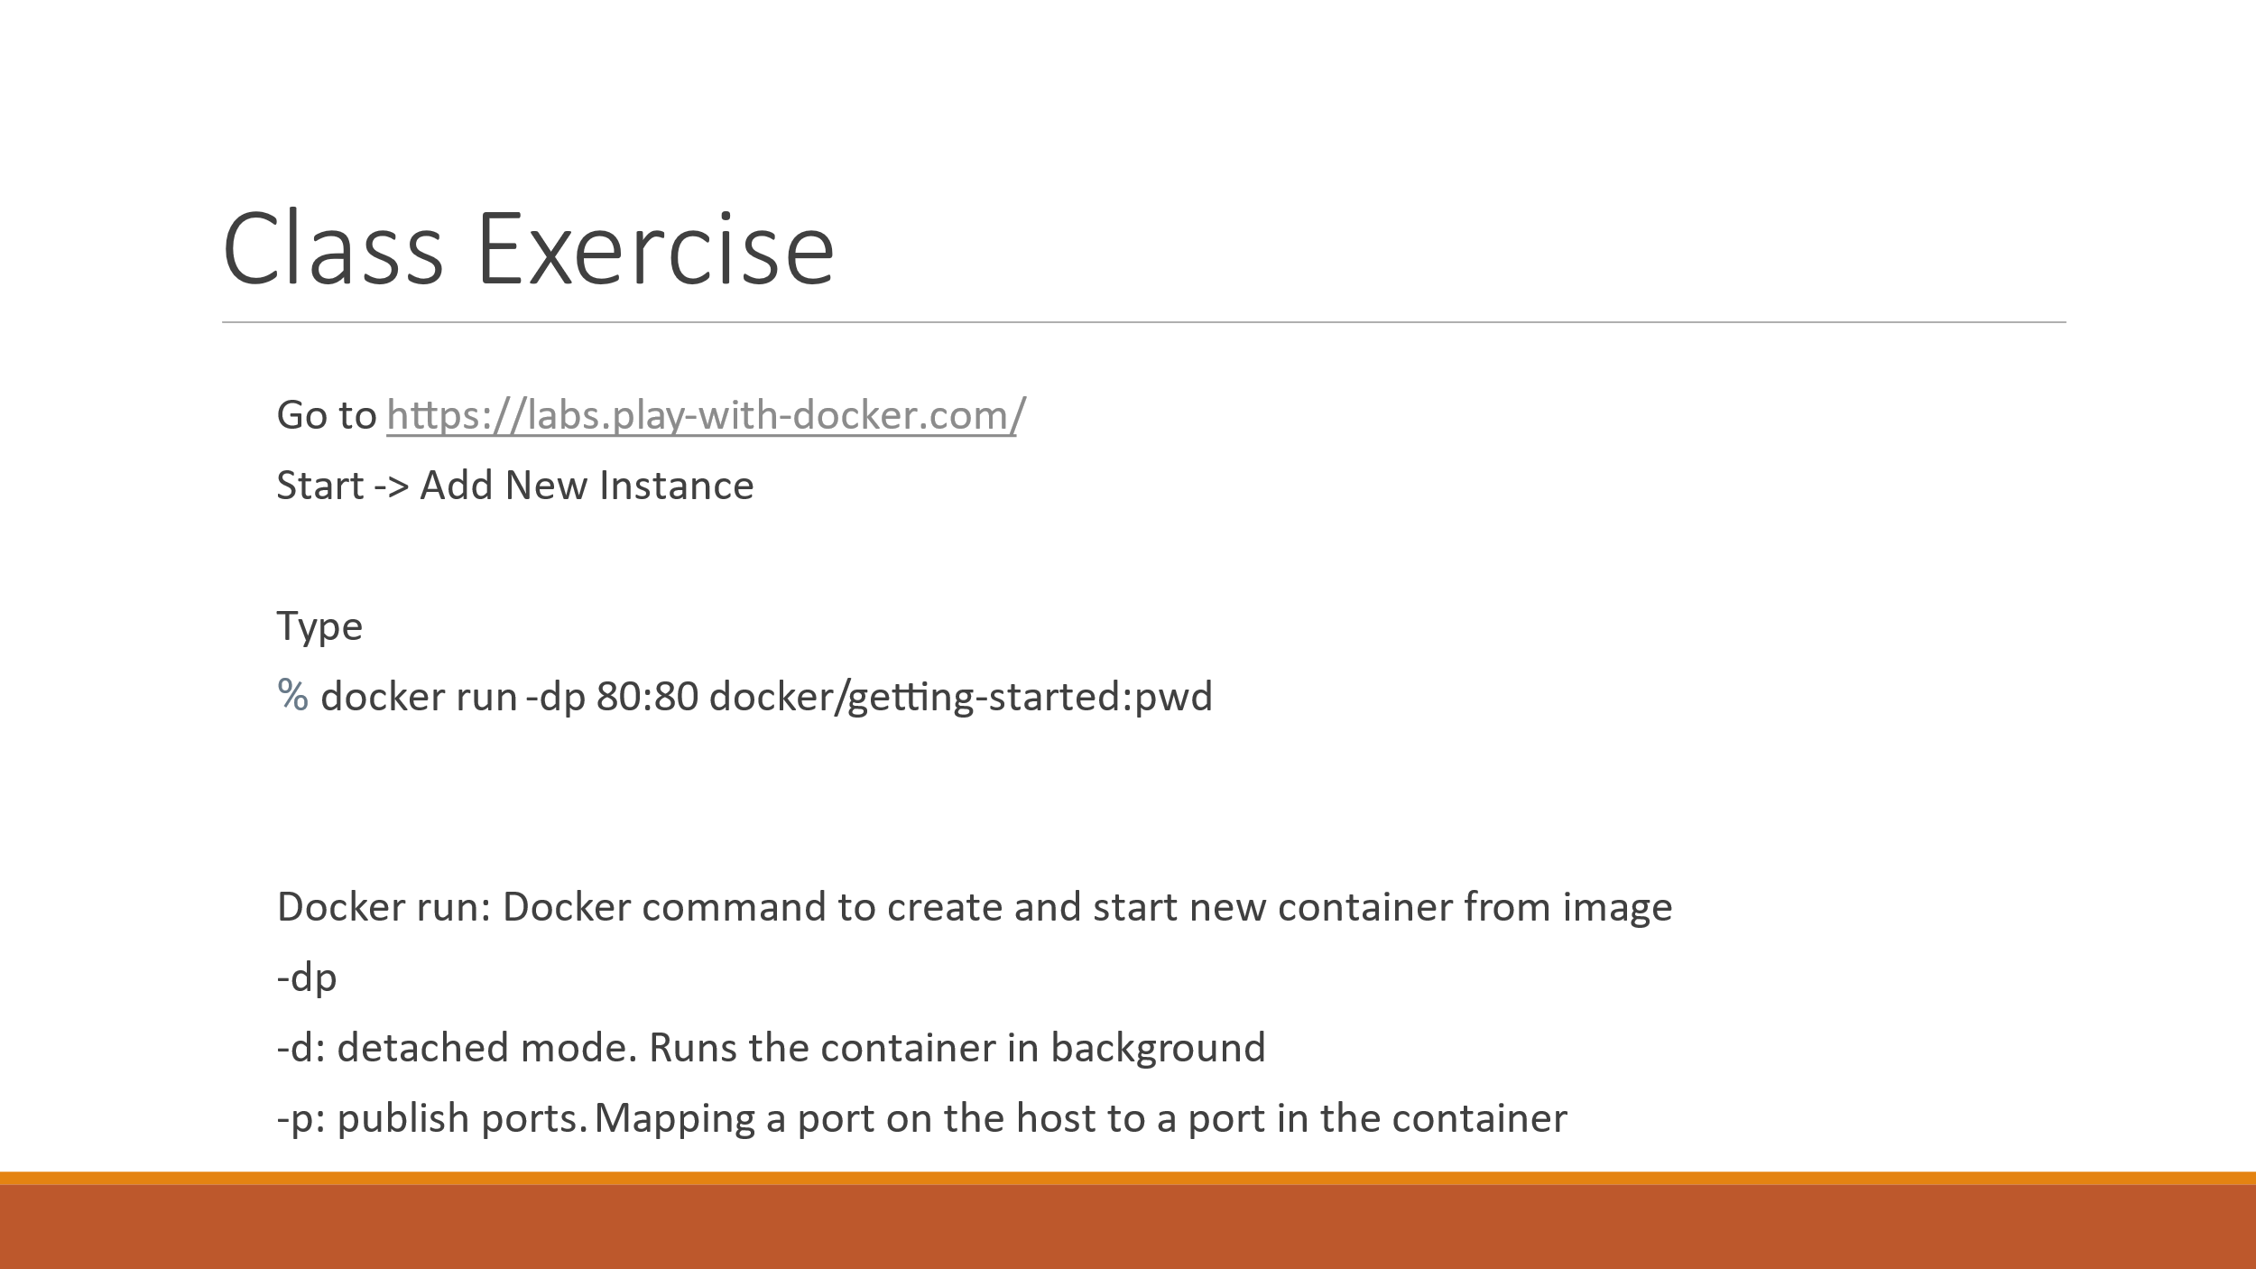Run docker in internet

Run the docker in the desktop

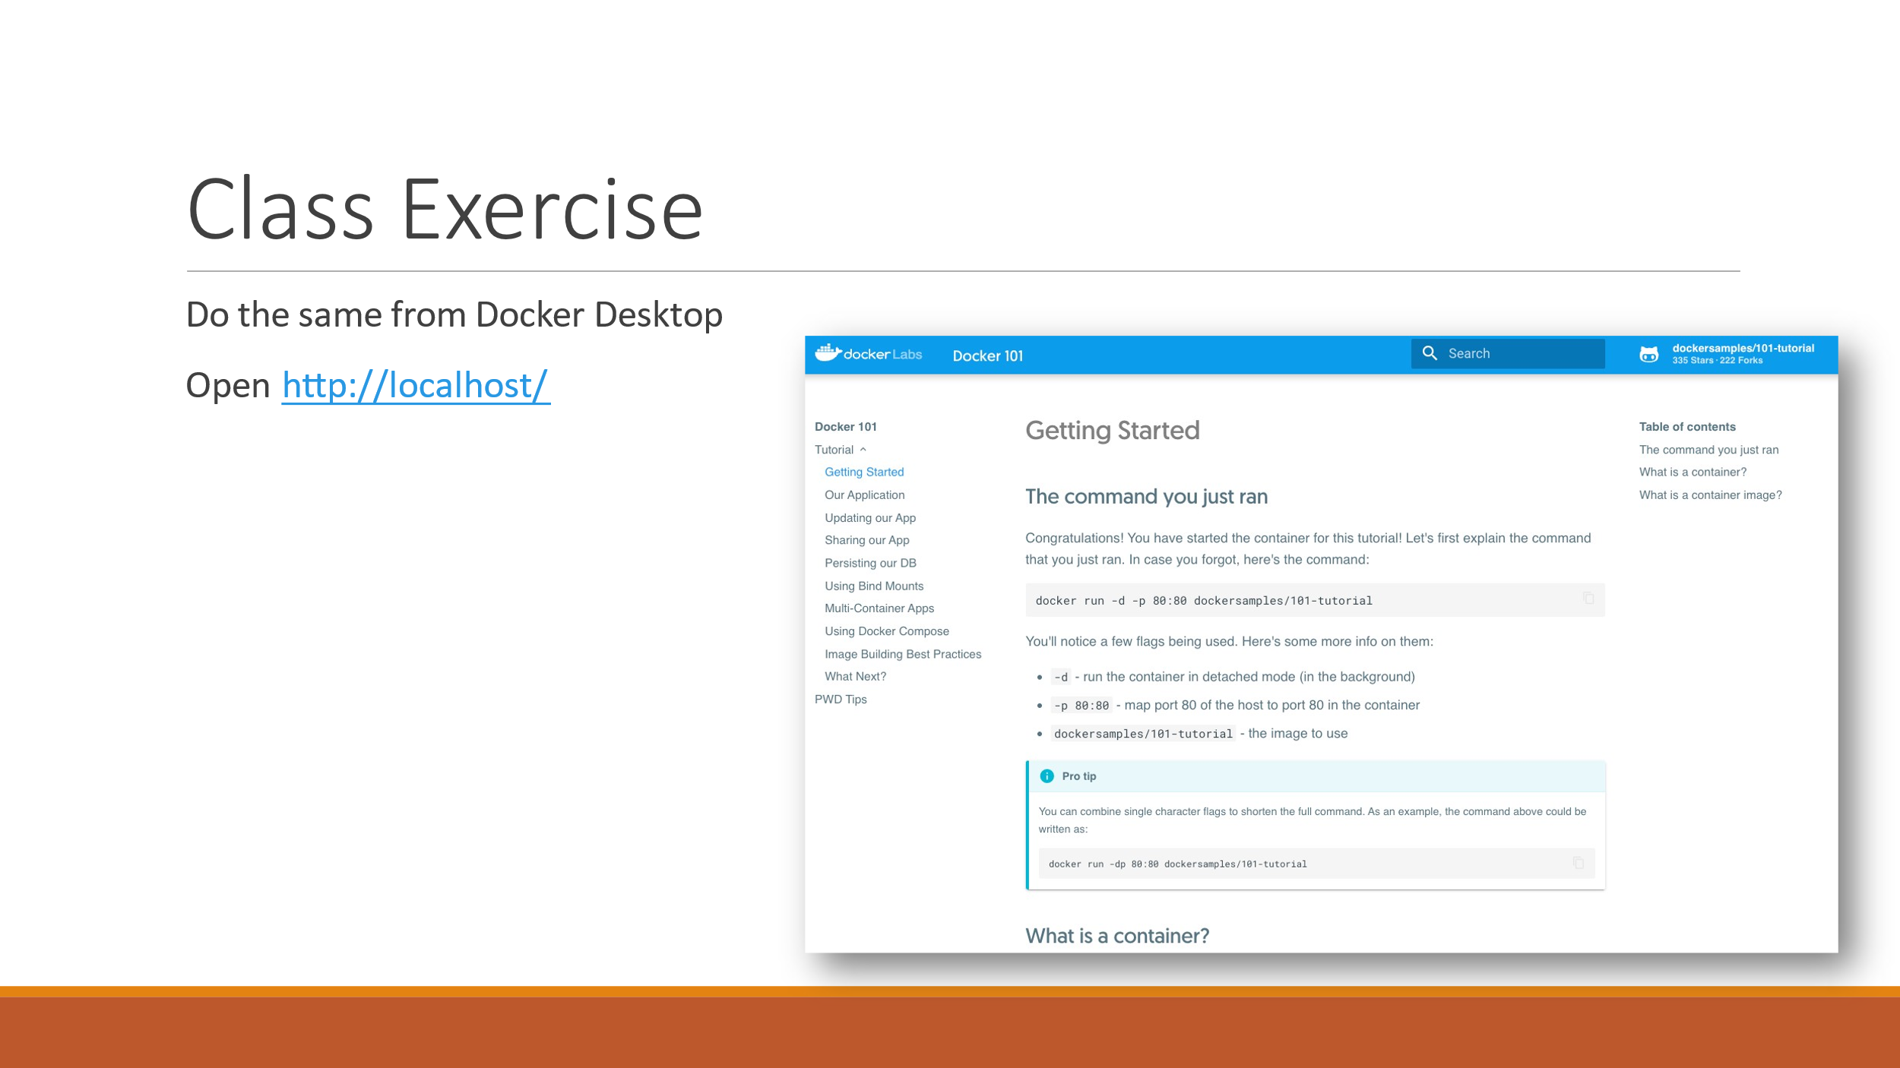

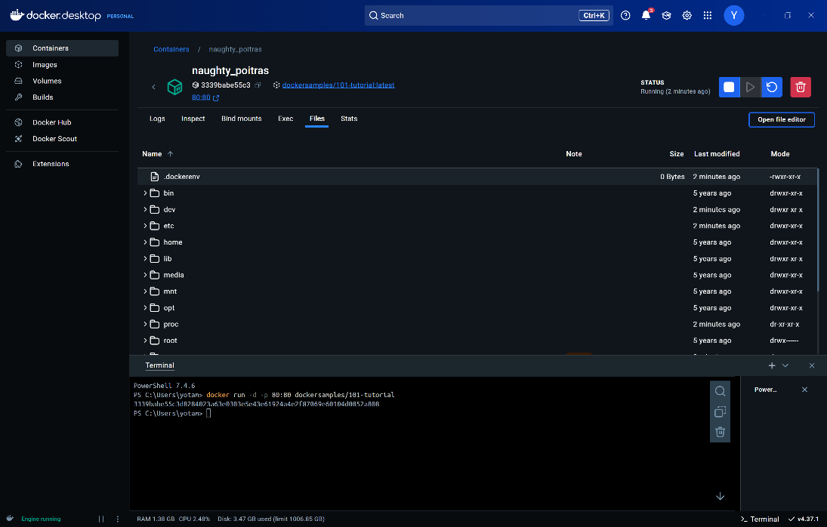

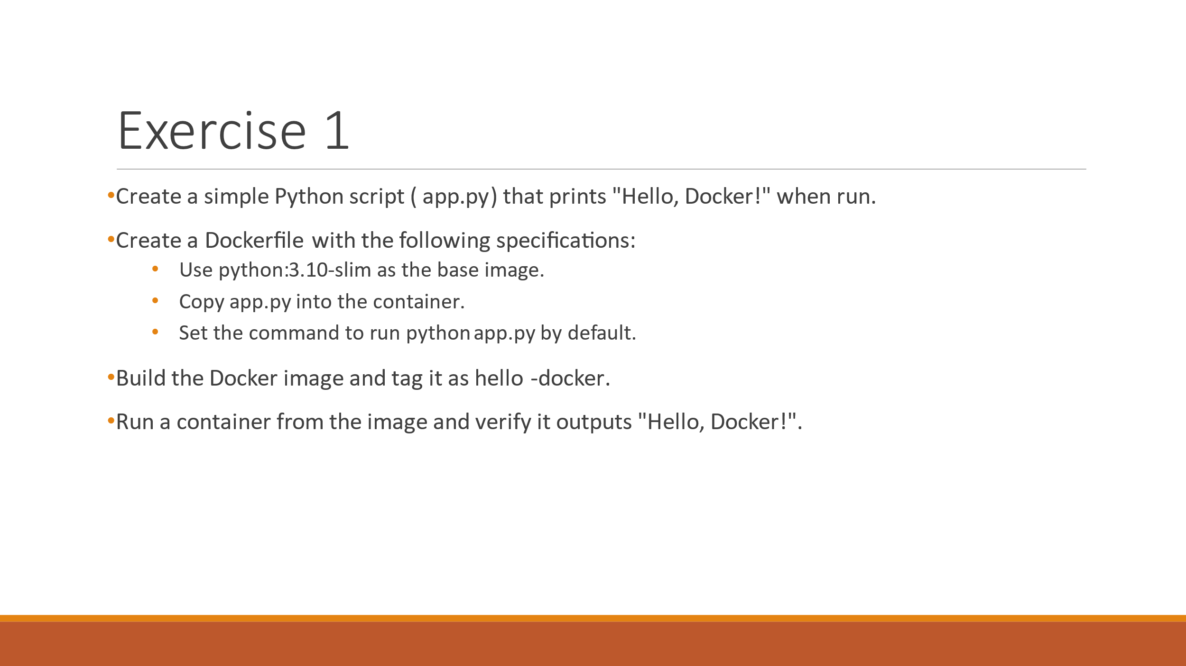

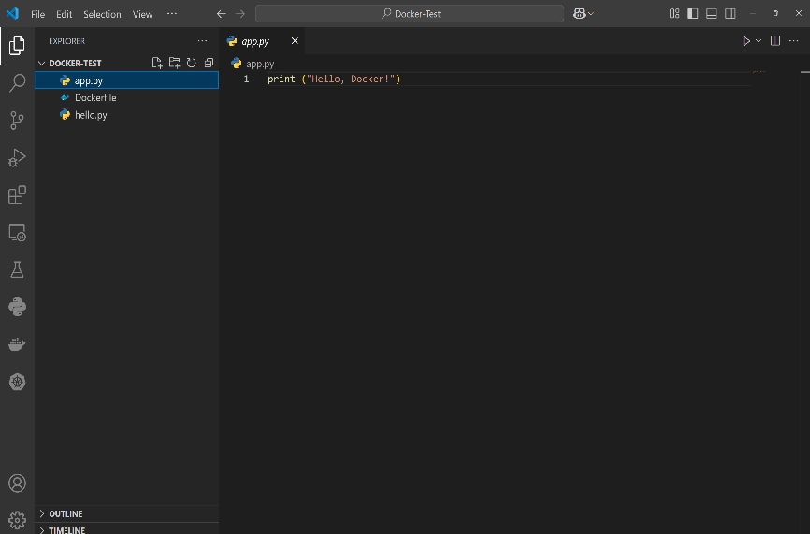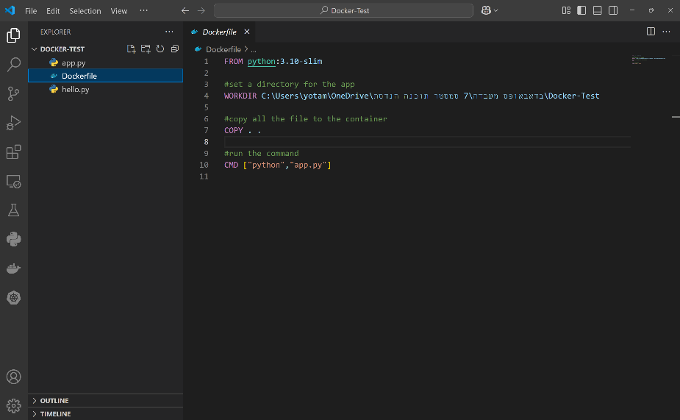

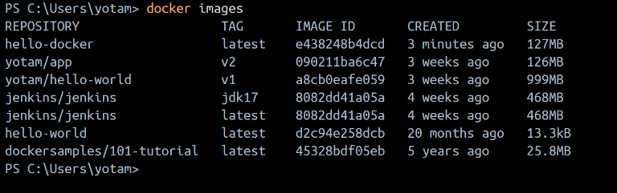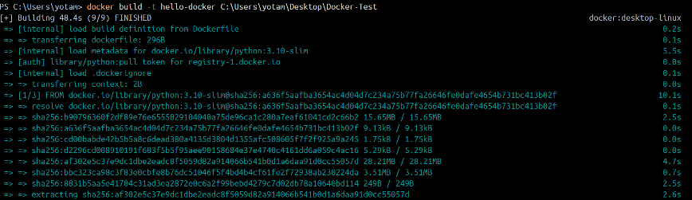build the image: check the image were create:

run the image

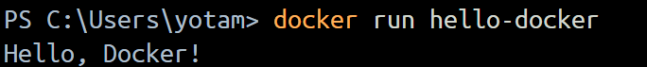

הרצאה 6. Jenkins – שקף 19,20

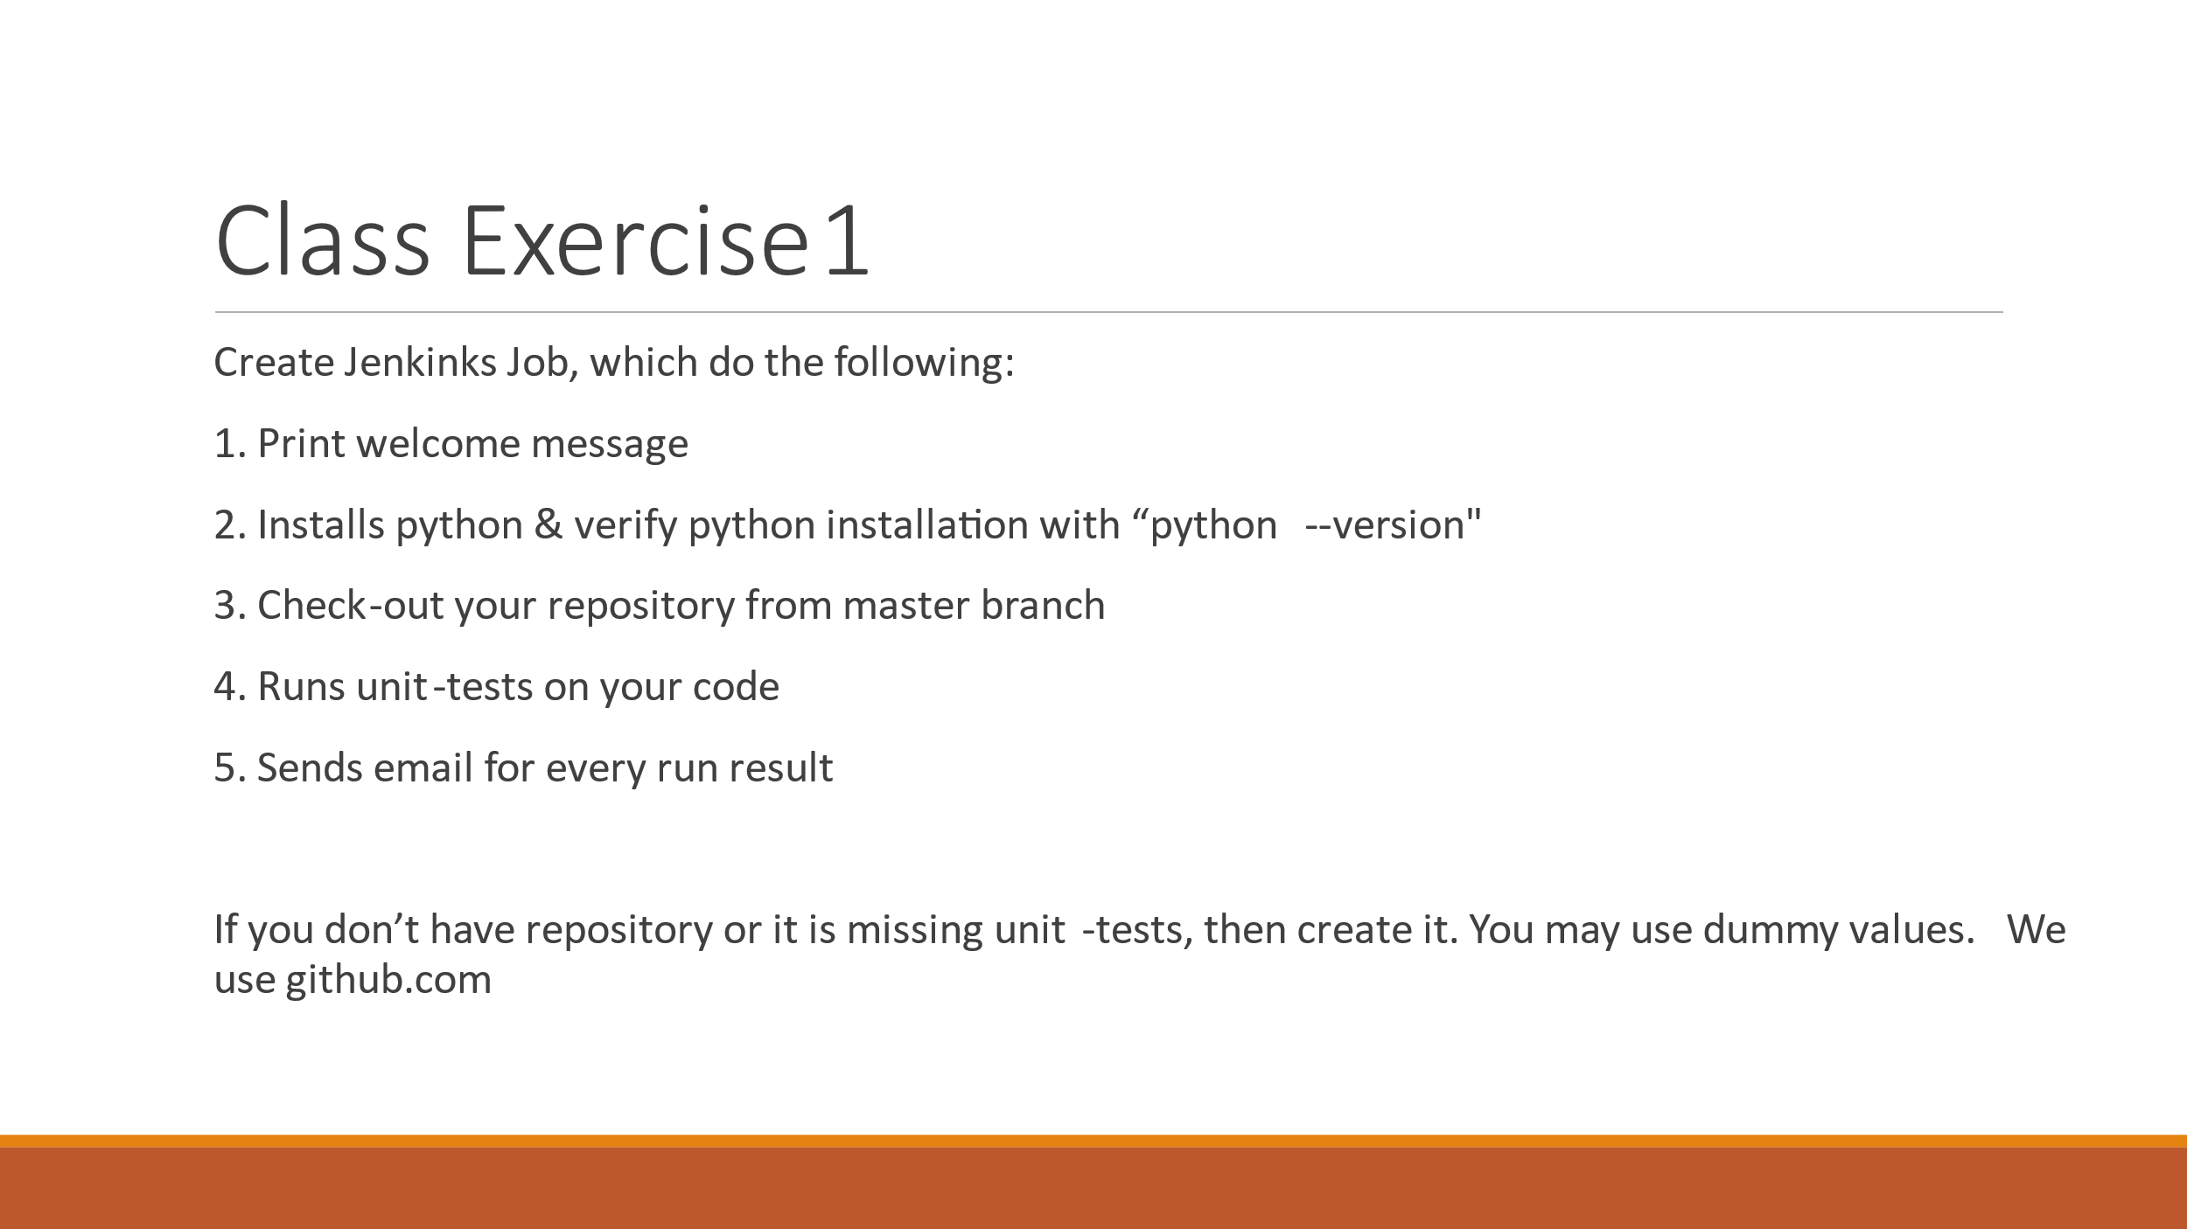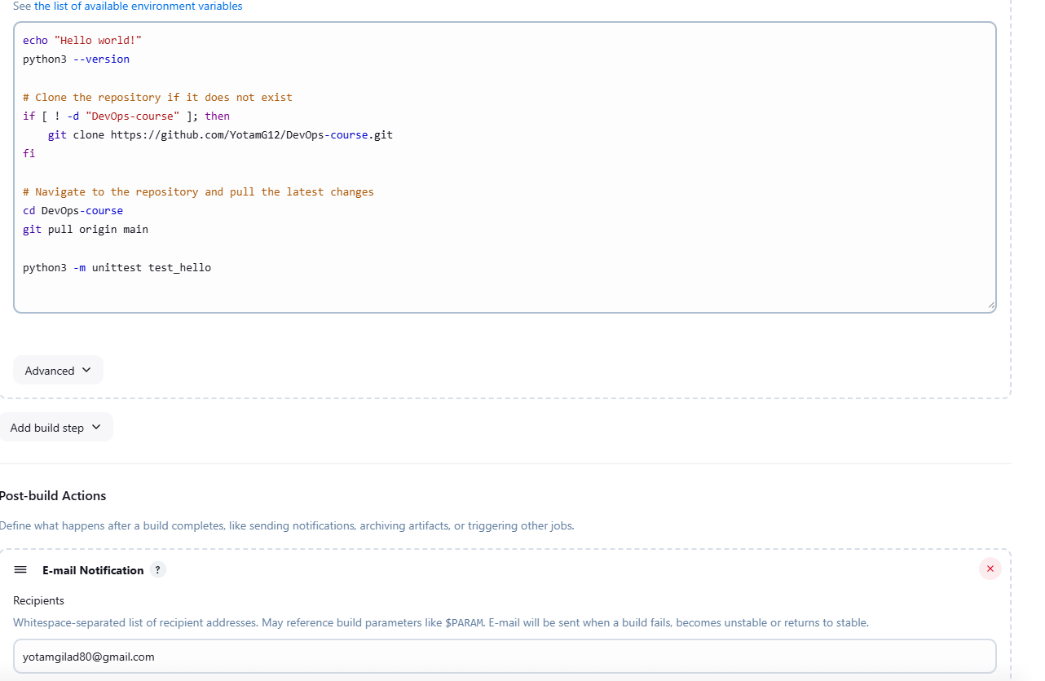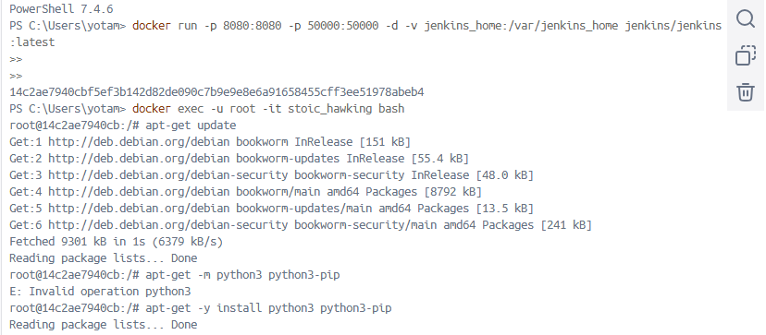run Jenkins in desktop docker in port 8080 and install python

A shell script to run all the command in one time

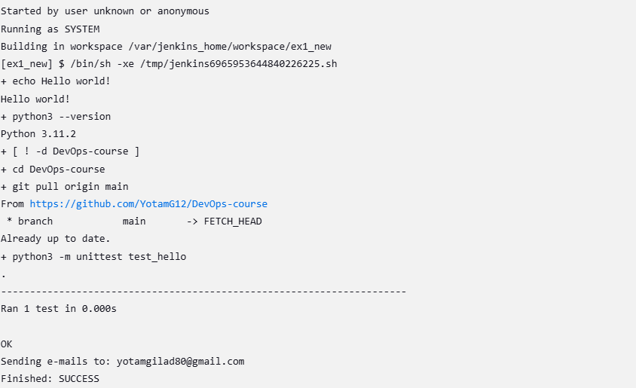

Email verify all the program was succeed

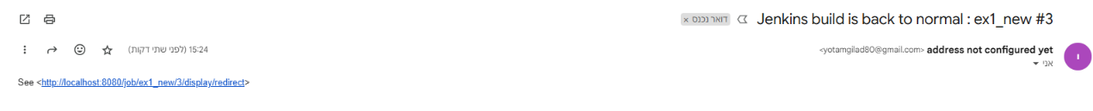

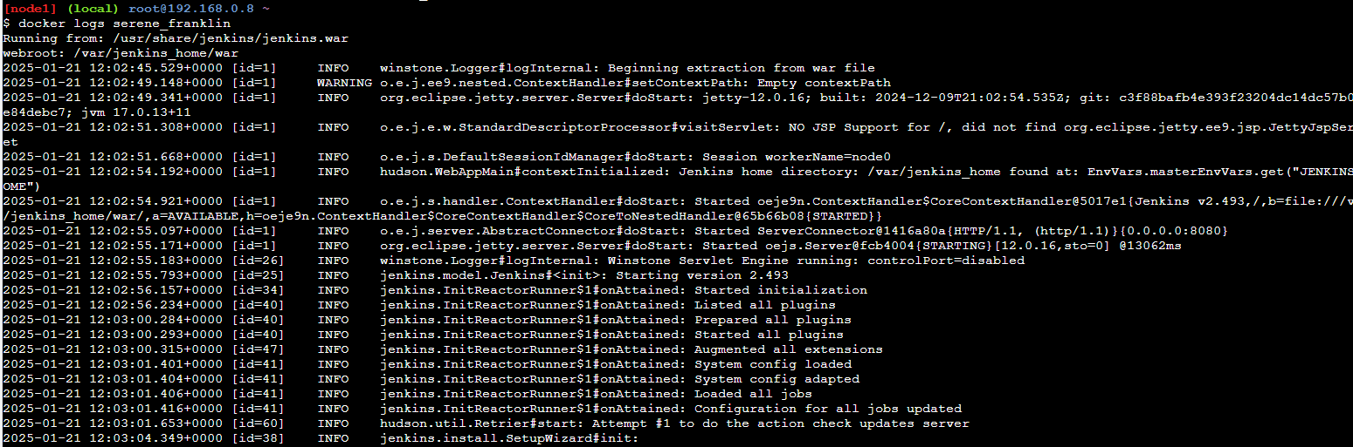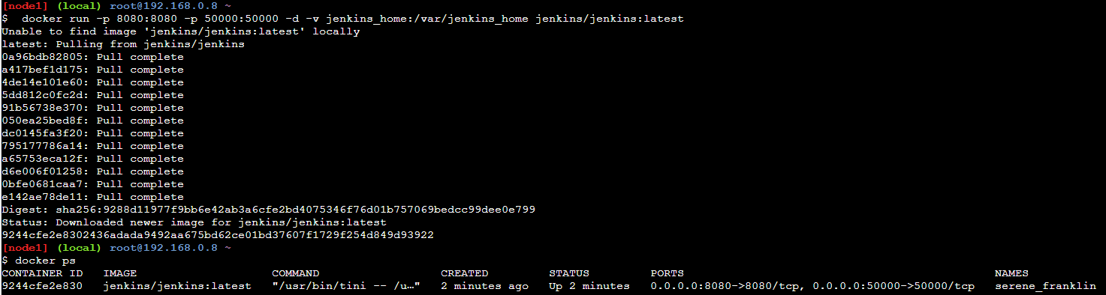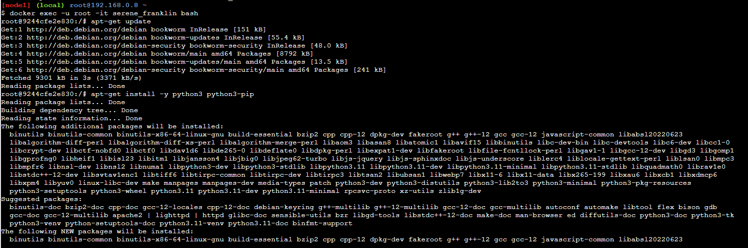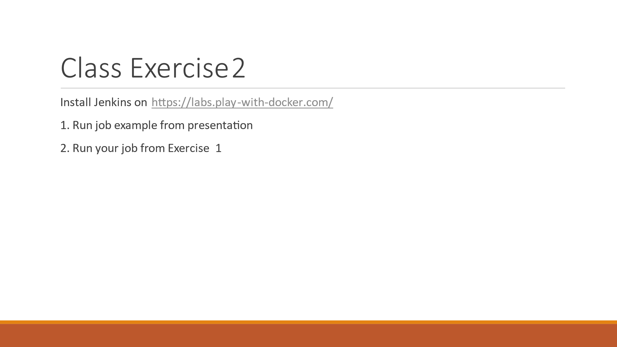

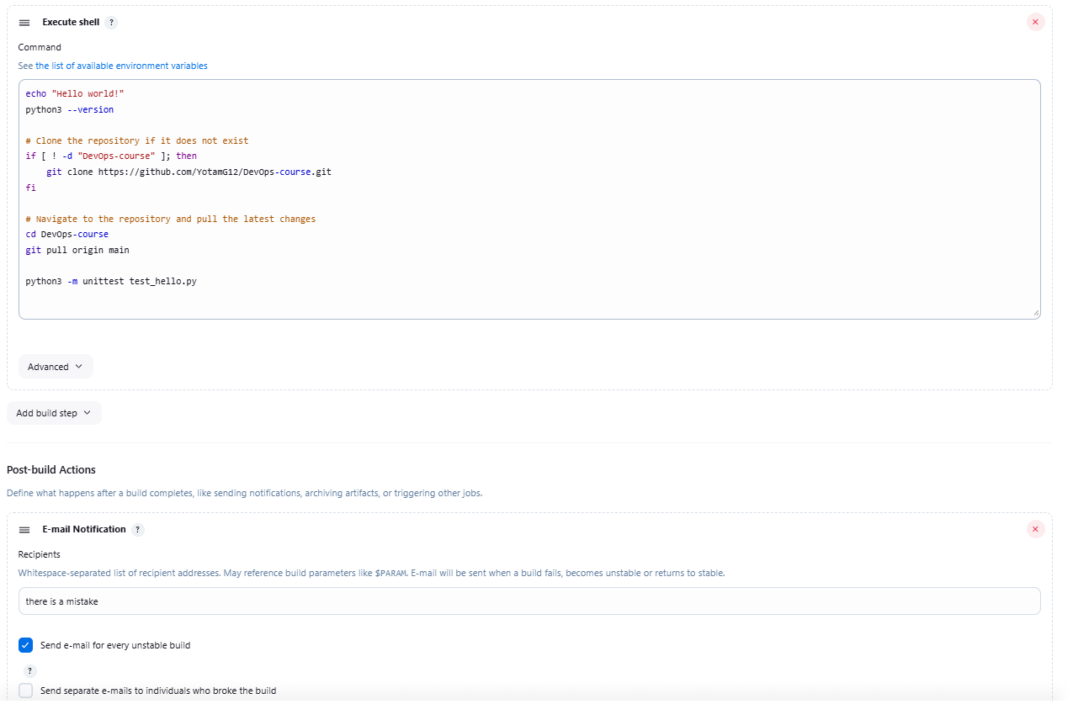running the same ex1 in web server

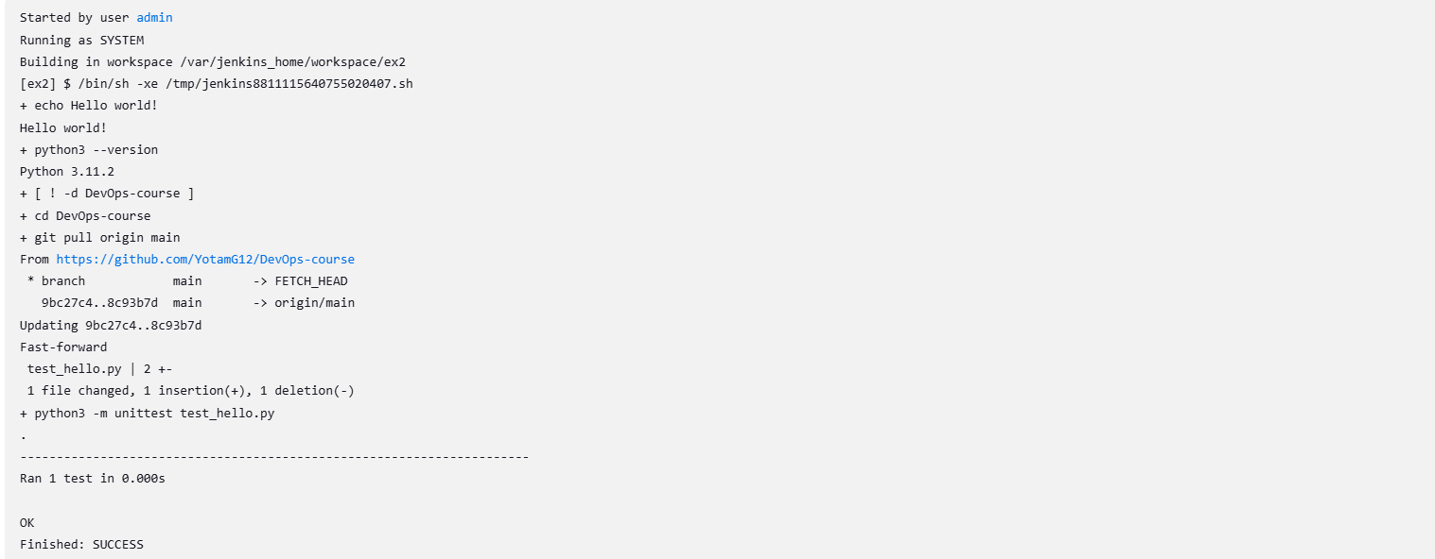

Run the example from the presentation

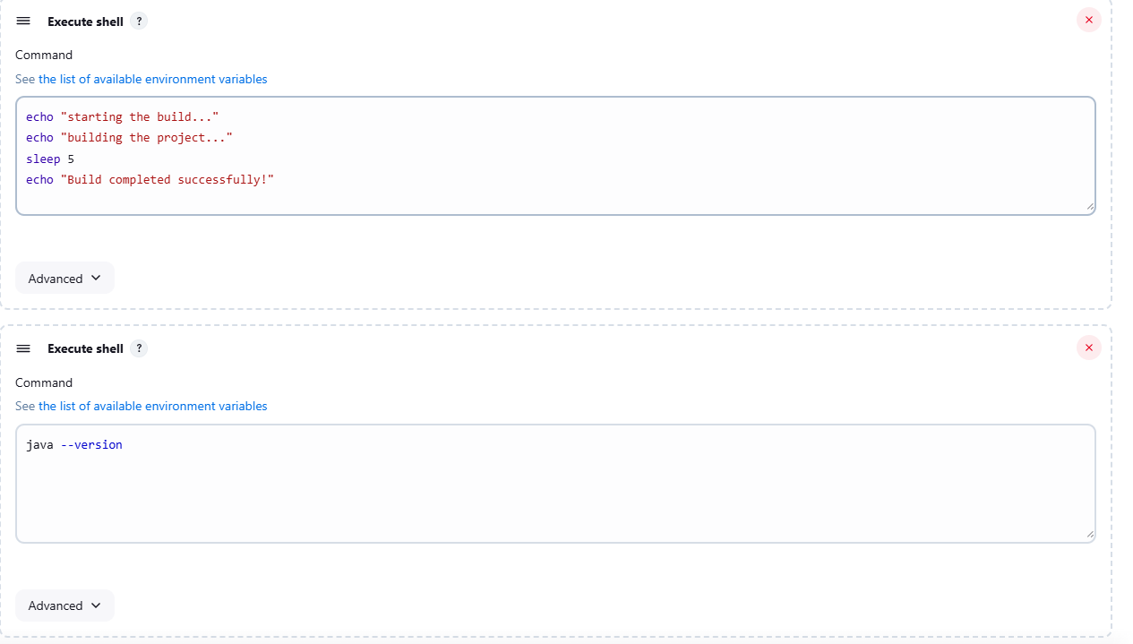

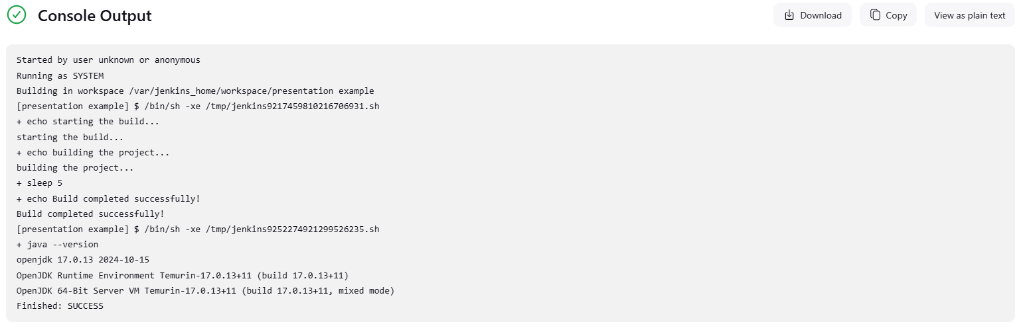

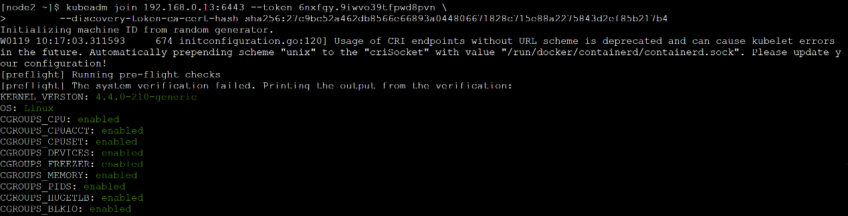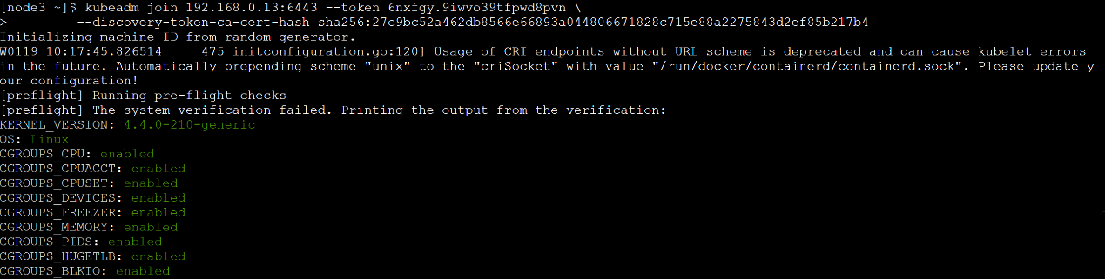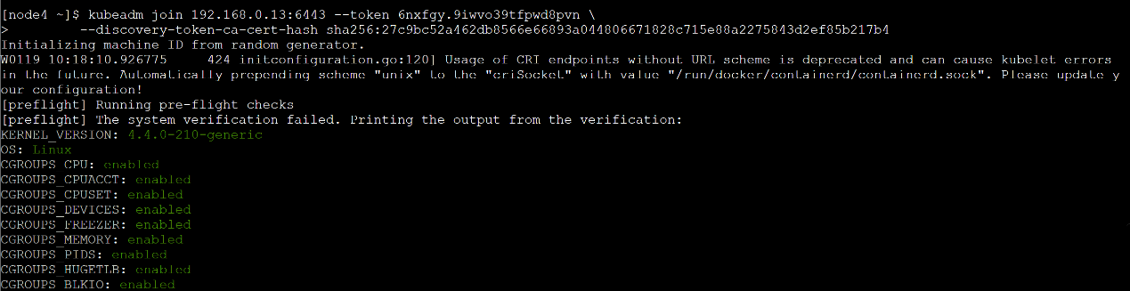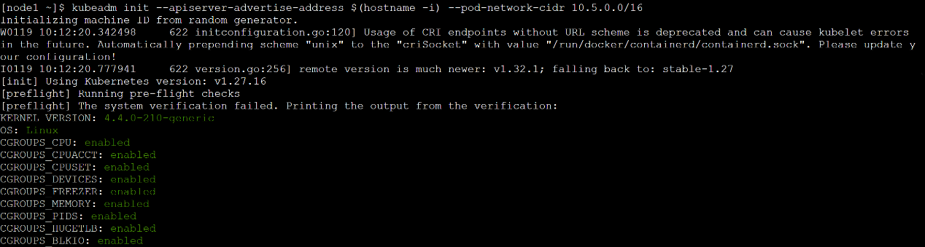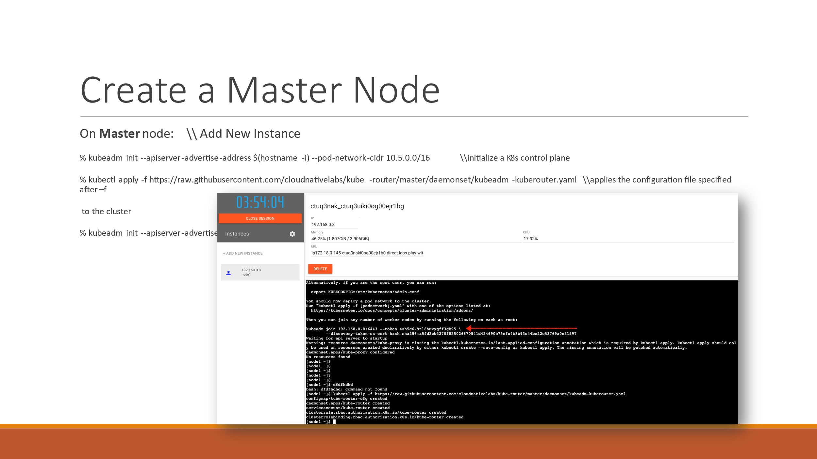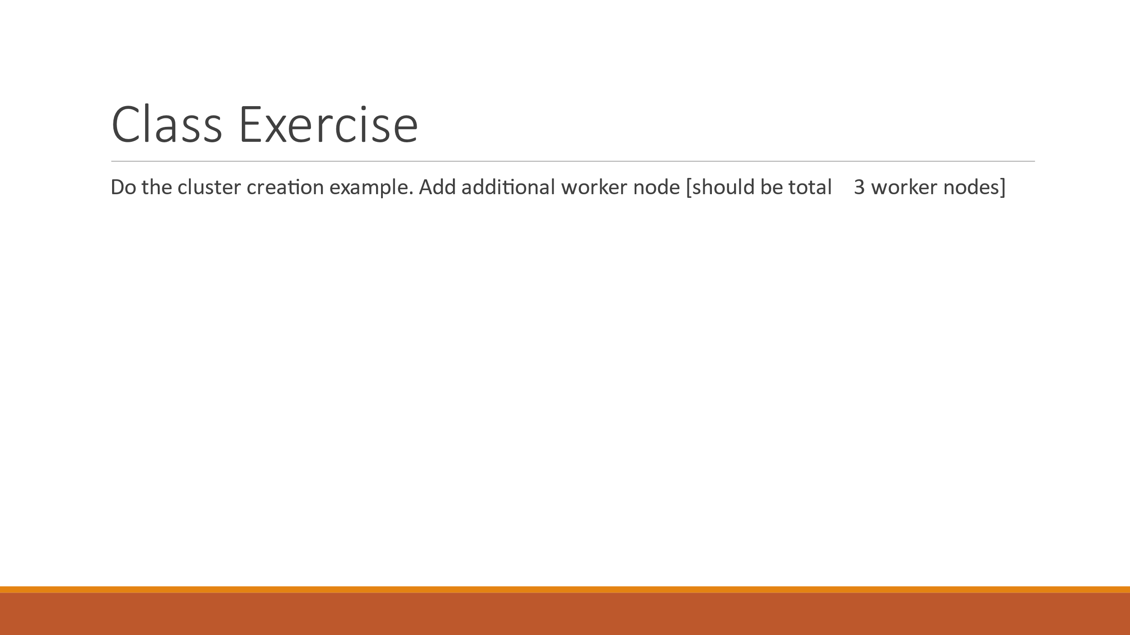הרצאה 7. Kubernetes – שקף 31,50,51

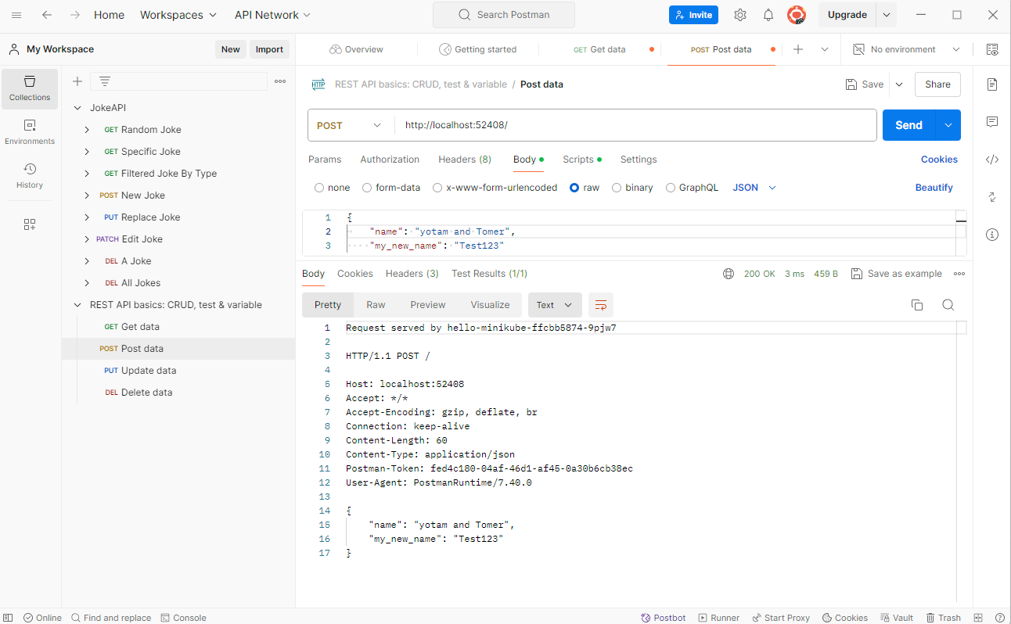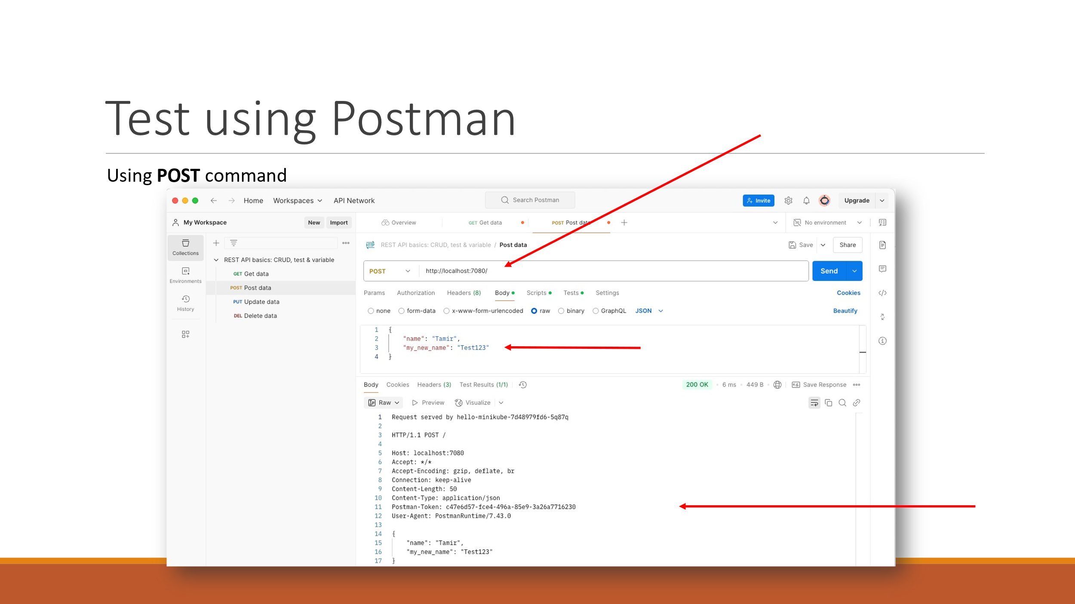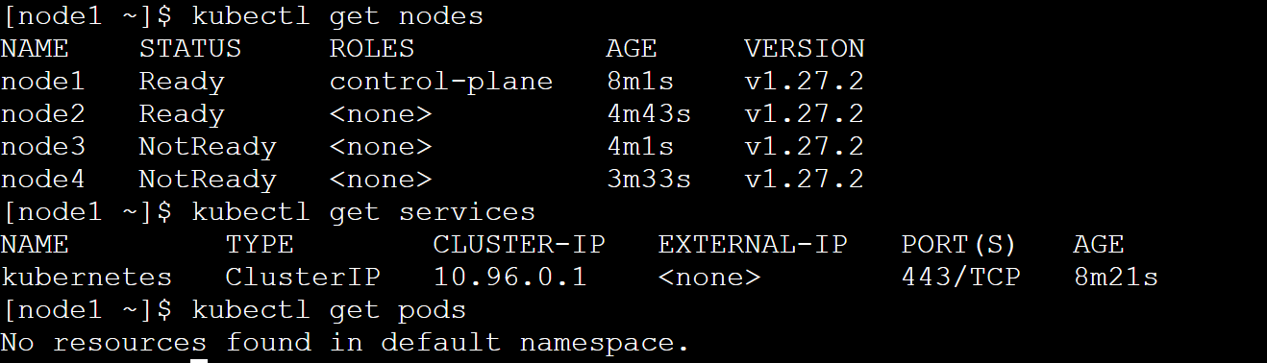

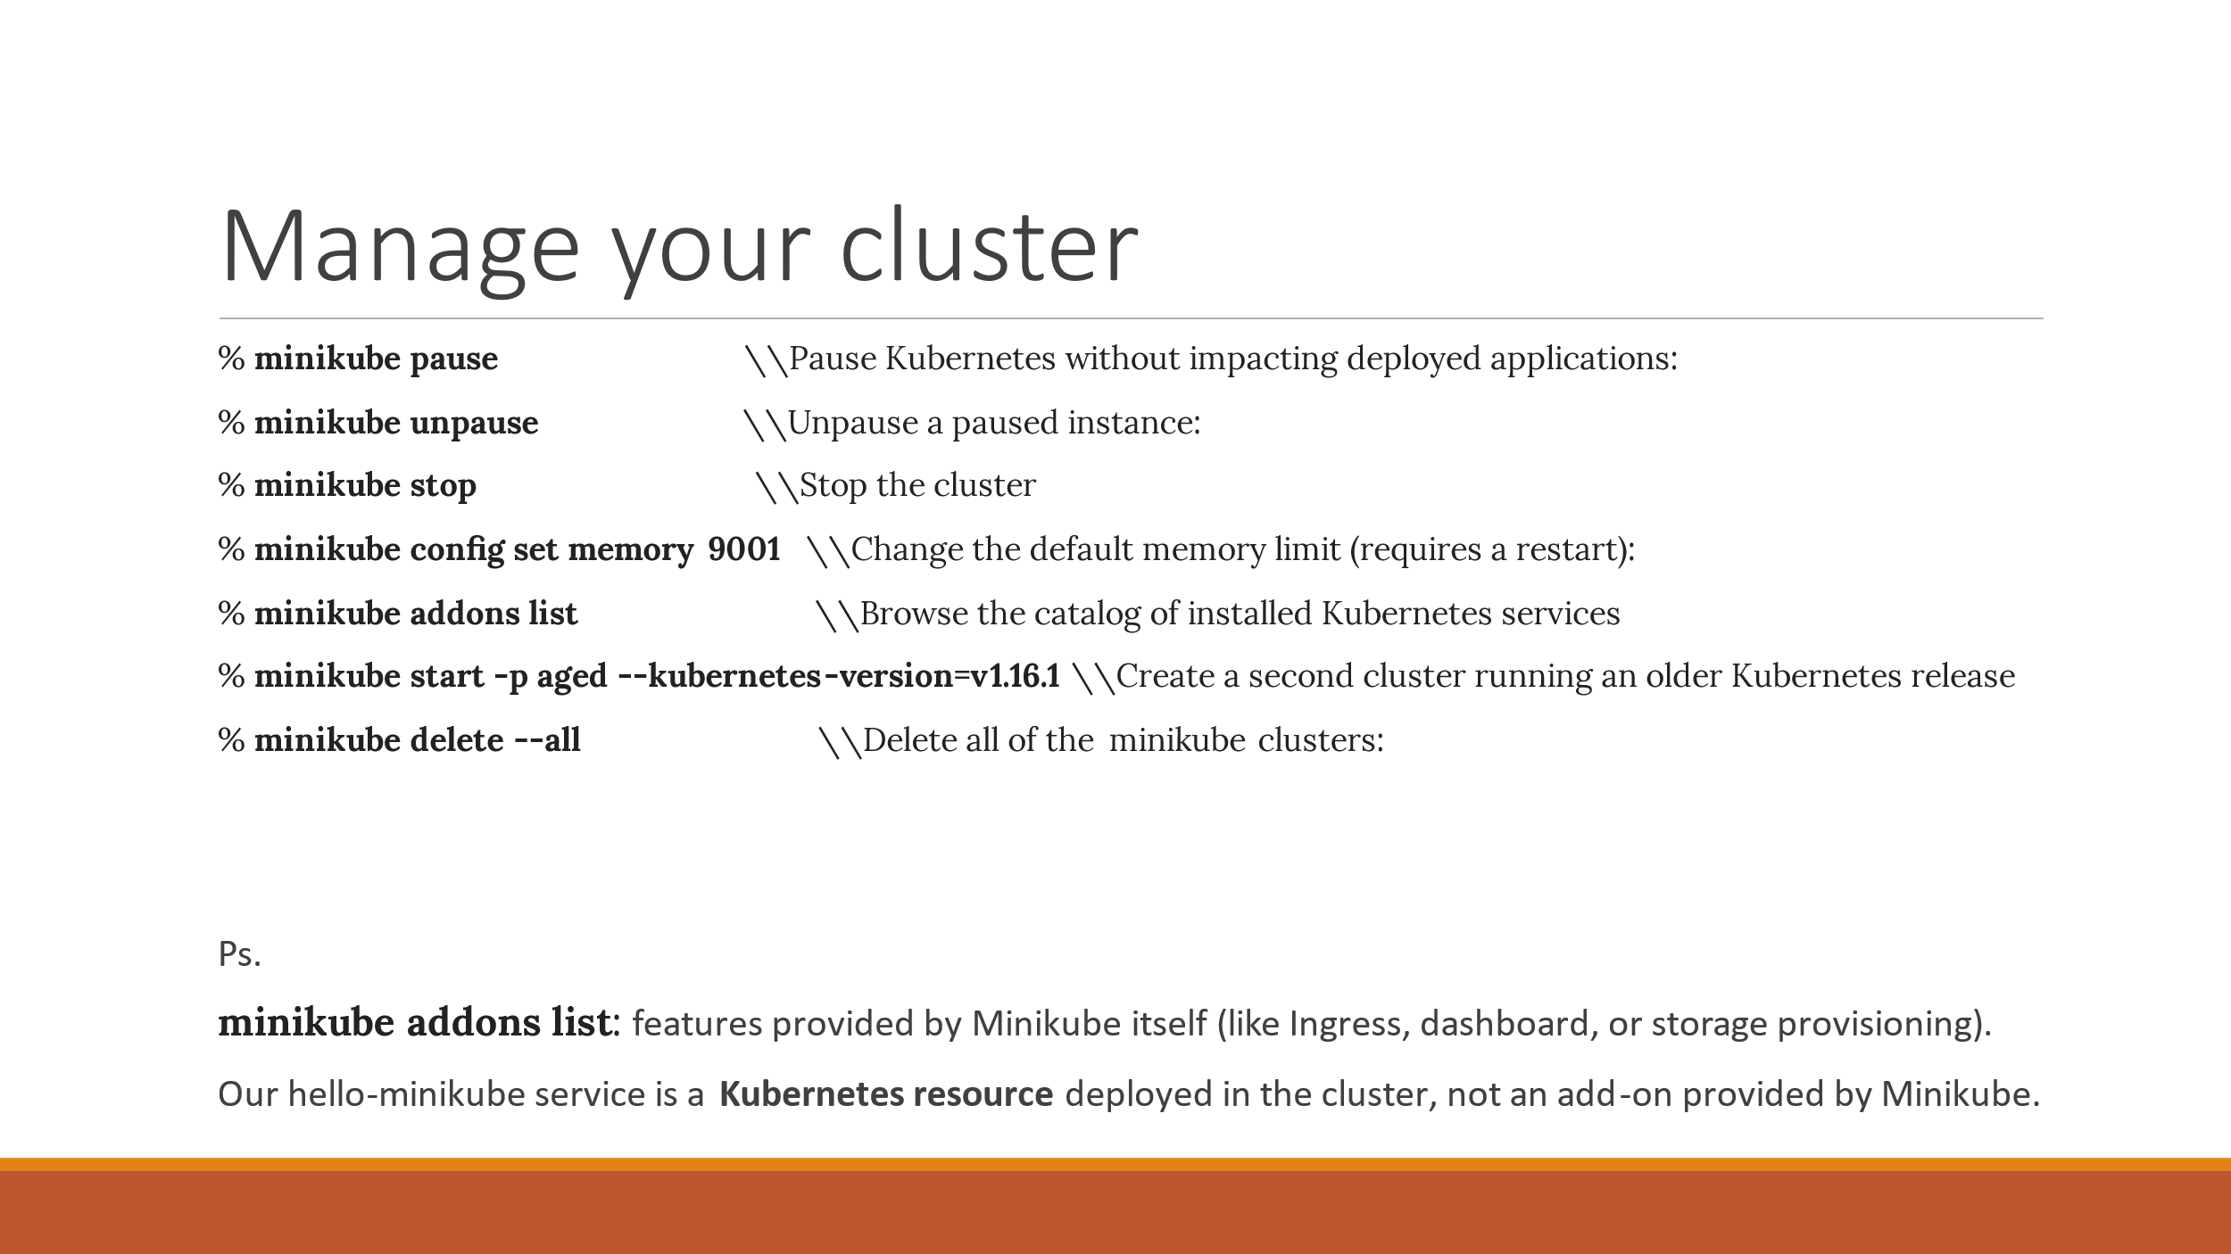

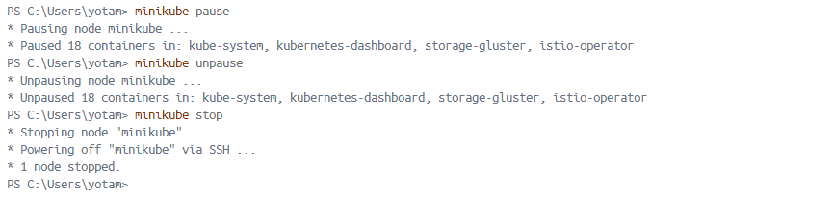

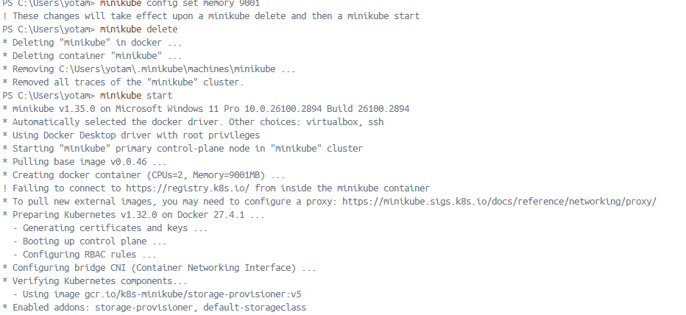

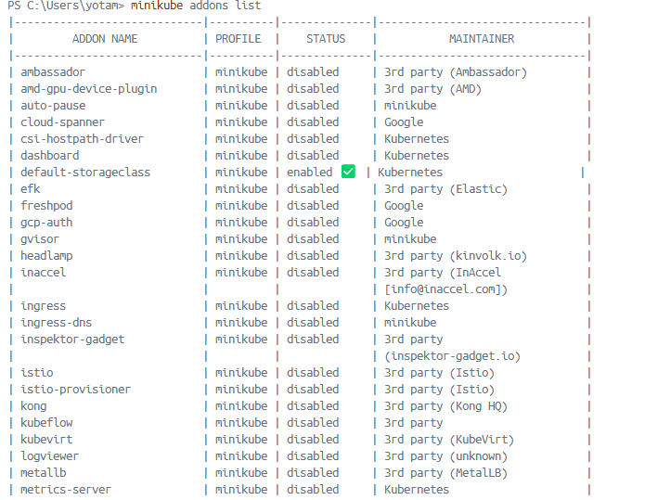

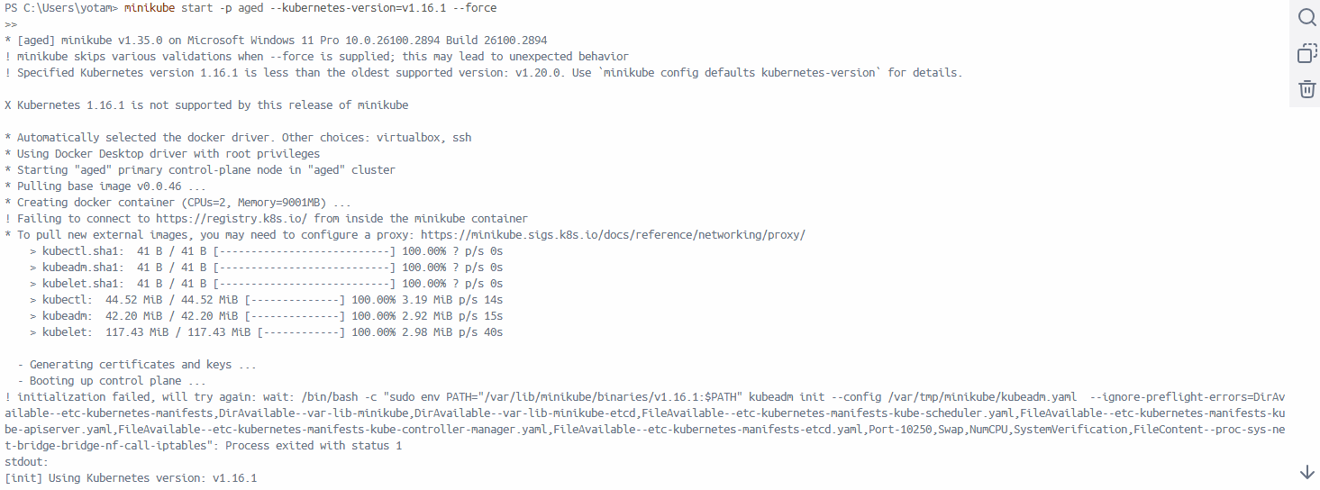

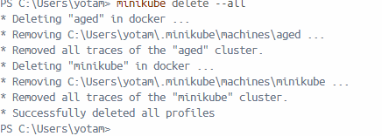

קישור לגיט:

<https://github.com/YotamG12/DevOps-course.git>